

Richmond House

79 Whitehall

London SW1A 2NS

*From the Parliamentary Under-Secretary of State for Health*

Deposited Papers Clerk

The Library

House of Commons

26 March 2015

Dear Deposited Papers Clerk

I attach a copy of the Agenda for Change pay scales for deposit in the Libraries of both Houses.

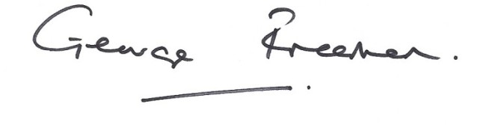

George Freeman