

DEFENCE ACADEMY
Training & Education
Statistical Analysis

Academic Year 2011/2012

Defence Academy HQ Training Cell

Email: TrainingCell.hq@defenceacademy.mod.uk

For Training Purposes Only
Defence Academy
INTRODUCTION

Aim
- The aim of this report is to provide an authoritative source of internal Defence Academy (DefAc) management information (MI). It gives an initial assessment of training delivered during the reporting period that might lead to more detailed analysis and highlights trends to inform future business decisions. It can also be used as a basis for answering queries from sources external to the DefAc.

Headlines
- This academic year saw a 6% increase in the number of training days delivered, mainly due to the addition of the Defence School of Languages (DSL) and the longer nature of its courses. There was a continuing (27%) fall in the number of students attending face-to-face (F2F) courses, partly the result of the College of Management and Technology (DA-CMT)’s generic leadership and management courses being phased out as the Civil Service Learning (CSL) portfolio was introduced. This is likely to have been a key driver for the greater reduction in throughput of civilian rather than military students. This reduction was also probably influenced by Travel and Subsistence (T&S) restrictions, smaller losses across the more military-focussed components and staff leaving on early release, bearing in mind that MOD has seen a 13.2% reduction in the civilian (SDSR) baseline during the 12 months since VERS began in Oct 11.

- Other headlines showed little change from last year, i.e. DA-CMT remains the DefAc’s biggest training provider, delivering 61% of training days to 86% of students and training over 99% of all civilian throughput; DE&S TLB remained the DefAc’s (as well as DA-CMT’s) primary customer; the military OF3 and civilian C2 groups were the largest by rank and grade; and four of the top five courses (in terms of training days) were JSCSC courses. A new training by Service category is included this year where percentages by training day were: Army (29%), RAF (12%) and RN/RM (11%) which is roughly in line with the actual ratio of the 3 services within MOD; the Civil Service share was 11%.

Background
- The process for collecting training data was implemented across all DefAc components for the first time during Academic Year (AY) 2010/11 and used to produce the first Statistical Analysis of DefAc Training report. This second report is based on data for AY 2011/12, i.e.1 Sep 11 to 31 Aug 12. The work is undertaken by the DefAc HQ Training and Education (T&E) Training Cell (hereafter referred to as the Training Cell).

Methodology
- The data used to compile this report was submitted to the Training Cell in an agreed format by nominated representatives from each of the components in accordance with the process policy document. The Training Cell collated data received into a master spreadsheet and thus built up a record of training undertaken across the DefAc over the reporting period.

Scope
- This report focuses on F2F, i.e. classroom based/tutor delivered, training and education. It provides detail such as numbers trained by Top Level Budget (TLB) and by rank/grade, the number of training days delivered, the military and civilian split, and the most/least popular courses. For the first time this year’s report includes numbers trained by output area and ‘quad-service’.

- It also gives an overview of non-F2F training undertaken by students. This is limited to the headline figures of student numbers and equivalent training days (ETDs), as it is not possible to obtain the same detailed breakdown that is available for F2F training.

- Where possible, the report provides comparisons with statistics submitted for the 2010/11 AY. Within DA-CMT, however, such comparisons are more limited because it has undergone substantial re-organisation during the reporting period. Headline figures across DefAc are highlighted in the main body of the report; supporting diagrams for each component can be found at the relevant annex.

Definitions
- Students who are external to Defence or whose TLB is unknown are grouped under ‘No TLB’. Military students with a rank below OF level are grouped in the category of ‘Other Ranks’; civilian students who do not fall into one of the specified grades are categorised as ‘Other Grades’. Students who are known to be either military or civilian, but whose rank or grade is not known, are grouped under ‘Unknown Ranks’ or ‘Unknown Grades’ accordingly. Students who cannot be categorised by quad-service or DTOEES are grouped under ‘No Service’. Students who cannot be otherwise categorised are classed as ‘Unknown’.

- F2F training days are calculated as the number of students attending a course multiplied by the duration (in days) of the course; non-F2F training days are defined in Table 2. The ‘students’ metric is not necessarily a total of separate individuals because one student can attend multiple courses during the reporting period.

SUMMARY DEFENCE ACADEMY STATISTICS

DefAc F2F Training by Component
- Figure 1 shows that DefAc trained a total of 25,993 students, delivering a total of 412,326 training days during the period 1 Sep 11 – 31 Aug 12. It shows the number of F2F students trained by each DefAc component, together with the corresponding number of training days. Both sets of figures are also expressed as a percentage of the total number of students/training days.

Total Students: 25,993 Total Training Days: 412,326
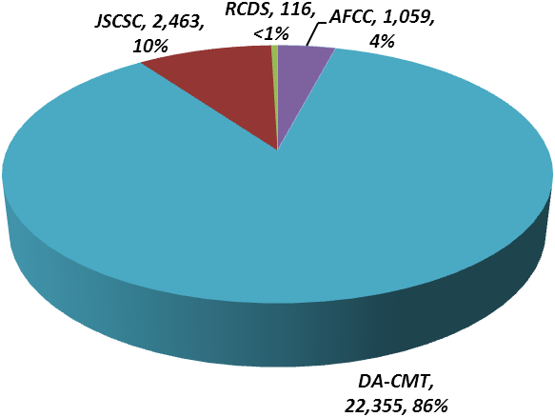
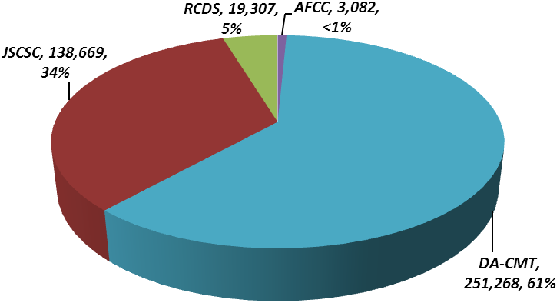

Figure 1 – F2F Student Numbers, Training Days and percentages of totals by Component

- The figures show that DA-CMT was DefAc’s biggest provider of training in terms of both numbers (86%) and training days (61%), with JSCSC training 10% of students across 34% of training days. RCDS and AFCC between them accounted for the remaining 5% of training days and students.

- This means that, in spite of its re-structuring (see DA-CMT section for more detail) and loss of courses to CSL, DA-CMT trained only a slightly decreased share (86%) of students compared to the 2010/11 reporting period (89%), retaining the highest percentage of students. In terms of training days, DA-CMT delivered a slightly increased share (61% from 56%) and JSCSC a slightly decreased share (37% to 34%).

- Thus the main change has been to training days where DA-CMT has increased its share due to the addition of DSL with its predominantly longer courses.

DefAc F2F Training and Comparisons
- Table 1 shows that DefAc trained 27% fewer students during this reporting period when compared with the previous academic year. In spite of the decrease in student numbers, there was a 6% increase in the number of training days over the same period.

Component |  | 2010/11 | 2011/12 | % Change
RCDS | Students | 115 | 116 |  | 1%
RCDS | Training Days | 19,469 | 19,307 |  | 1%
JSCSC | Students | 2,879 | 2,463 |  | 14%
JSCSC | Training Days | 146,844 | 138,669 |  | 6%
DA-CMT | Students | 31,656 | 22,355 |  | 29%
DA-CMT | Training Days | 219,437 | 251,268 |  | 15%
AFCC | Students | 854 | 1,059 |  | 24%
AFCC | Training Days | 2,743 | 3,082 |  | 12%
Totals | Students | 35,504 | 25,993 |  | 27%
Totals | Training Days | 388,493 | 412,326 |  | 6%

Table 1 – F2F Students and Training Days by Component compared with 2010/11

- DA-CMT, with a student throughput fall of 29%, experienced the largest decrease in student numbers and yet the largest increase in training days (15%). AFCC was the only component to increase both student throughput (24%) and training days (12%) whilst JSCSC was the only component to see falls in both, training 14% fewer students over 6% fewer training days. RCDS was the most static, experiencing only a 1% increase in students over 1% fewer training days.

- Approximately two thirds of DA-CMT’s fall in student numbers can be explained by the phasing out of generic leadership and management training as it transferred to CSL. The remaining third is split largely between Acquisition and Technology training and is probably due to budget restrictions (particularly on T&S) and loss of staff through redundancy and early release schemes.

DefAc non-F2F Training and Comparisons
- Table 2 shows that non-F2F training in the DefAc was delivered to 80,473 students and amounted to 63,711 ETDs. This is a significant fall of 45% in student numbers with a corresponding decrease of 36% in training days due largely to the falls in DA-CMT’s Business eLearning.

- It is assumed that DA-CMT’s former Business element remained the largest provider of non-F2F training during the reporting period both in terms of students and ETDs, although the totals shown are estimates as no figures were reported this year. Based on the downward trend in Business F2F student throughput (of 49%), its non-F2F figures have been estimated at 50% of last year’s totals.

- As with F2F courses, JSCSC experienced falls in non-F2F training. Military Knowledge (classed under DA-CMT (Technology)) was the only non-F2F training to show increases in both students and ETDs, due to the addition of Royal Military Academy Sandhurst (RMAS) training (pre-learning for officer cadets).

- Acquisition figures remained fairly static partly due to the fact that eLearning is an integral part of Acquisition’s blended approach. Other reasons include on-line training being undertaken in preference to F2F because of T&S restrictions or other job-related uncertainties.

Component |  | 2010/11 | 2011/12 | % Change
JSCSC | Students | 1,315 | 1,255 |  | 5%
JSCSC | ETDs | 6,467 | 5,220 |  | 19%
DA-CMT  (Acquisition) | Students¹² | 10,929 | 11,294 |  | 3%
DA-CMT  (Acquisition) | ETDs | 13,751 | 13,660 |  | <1%
DA-CMT  (Business) | Students¹² | 130,842 | 65,421 |  | 50%¹⁵
DA-CMT  (Business) | ETDs | 72,362 | 36,181¹⁵ |  | 50%¹⁵
DA-CMT  (Technology) | Students¹² | 2,079 | 2,503 |  | 20%
DA-CMT  (Technology) | ETDs | 7,524 | 8,650 |  | 15%
Totals | Students | 145,165 | 80,473 |  | 45%
Totals | ETDs | 100,104 | 63,711 |  | 36%

Table 2 – Non-F2F Students and Training Days compared with 2010/11

- Neither AFCC nor RCDS reported any non-F2F training.

DefAc F2F and non-F2F Totals
- Table 3 shows that total DefAc business during the reporting period saw 106,466 students undertake different types of training and education that amounted to 476,037 training days. This was a drop in student numbers of 41% but a smaller fall in training days of 3%.

DefAc |  | 2010/11 | 2011/12 | % Change
Grand  Total | Students | 180,669 | 106,466 |  | 41%
Grand  Total | Training Days | 488,597 | 476,037 |  | 3%

Table 3 – DefAc F2F and non-F2F Totals compared with 2010/11

DefAc F2F Training by Output
- Figure 2 shows how the totals of 25,993 students and 412,326 training days are broken down by output area. Acquisition and Business courses trained the highest proportion of students (26% and 23%) whereas Command, Staff and Strategy (Comd, Staff & Strat) courses delivered the most training days with 38% of the total. This is due to predominantly shorter Acquisition and Business courses and the longer nature of Comd, Staff & Strat (within RCDS and JSCSC).

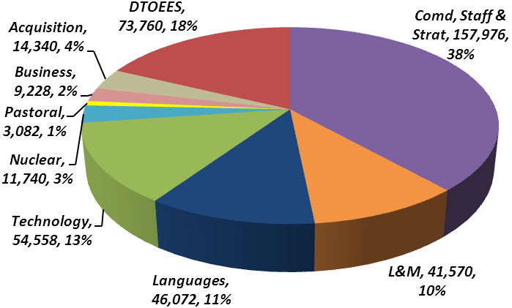
Total Students: 25,993 Total Training Days: 412,326
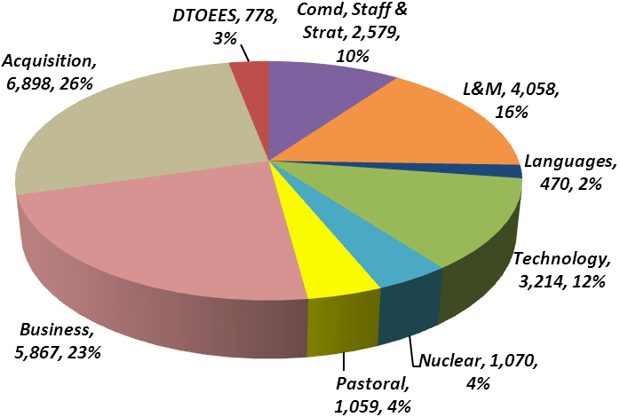

Figure 2 – F2F Student Numbers, Training Days and percentages of totals by Output

DefAc F2F Training by TLB
- Figure 3 shows the breakdown of students and training days by TLB. DE&S provided the greatest number of students at 32% but consumed 7% of training days, the same percentages as last year; all the DE&S students were reported by DA-CMT. Once again Army Command accounted for the highest number of training days with 22% (to 18% of students), compared with last year’s 23% of training days to 18% of students. The split of students for the remaining TLBs remained fairly static (last year’s figures in brackets): Head Office 9% (13%), Joint Forces Command (JFC) 1% (<1%), Defence Infrastructure Organisation (DIO) 2% (2%), Navy 7% (6%) and Air 12% (13%).

- The TLBs of Head Office and JFC were new at the start of Apr 12 when Centre TLB was dismantled and Chief of Joint Operations (CJO) was subsumed within JFC. Because these statistics are based on an academic rather than a financial year, only the new categories are displayed but combine elements of both old and new.

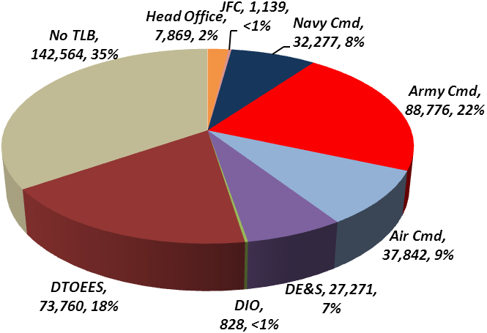
Total Students: 25,993 Total Training Days: 412,326
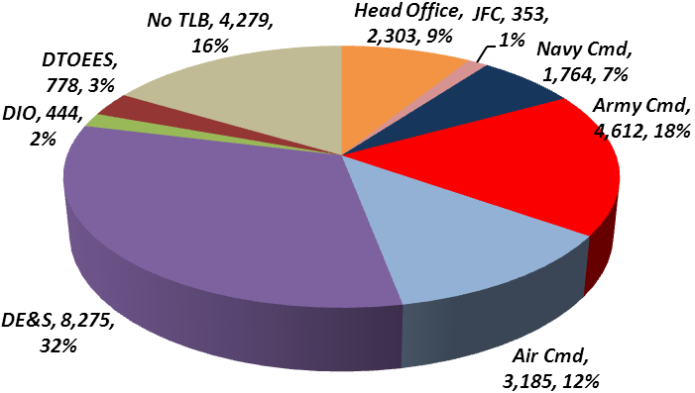

Figure 3 – F2F Student Numbers, Training Days and percentages of totals by TLB

- An executive decision was taken to include DTOEES in this year’s DefAc training totals (instead of reporting them separately as last year). The addition of this category, with 73,760 days accounting for 18% of the total, makes it difficult to draw too many conclusions about TLB training days. The addition of DSL has also affected the split as no TLB data was reported, thus all 46,072 training days (11%) fell into the ‘No TLB’ category, as did the 38,052 pre-2011/12 Post Graduate (PG) training days (9%). Both these factors help to explain the increase in this category to 35% from last year’s 23%. The student split is less affected as the numbers for DTOEES (778, 3%), DSL (406, 1.5%) and PG (906, 3.5%) are relatively small.

DefAc F2F Training by Student Base
- As shown by Figure 4, MOD civilians accounted for the highest percentage of students with 45% of the total against 42% MOD military. This is a more even split than last year when 53% were civilians and 36% military. This reflects a bigger reduction in the overall throughput of civilian students (compared with military), largely explained by the bigger than average fall in student numbers on DA-CMT’s predominantly civilian courses, particularly in the Business and Acquisition areas.

- However, of the 11,560 civilian students, more than 99% (11,492) were trained by DA-CMT with only 68 (<1%) attending the other three components. This translates into 94% and 6% of training days due to the longer nature of RCDS and JSCSC courses.

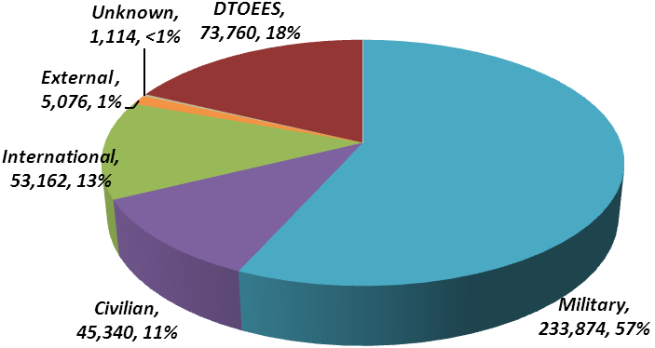
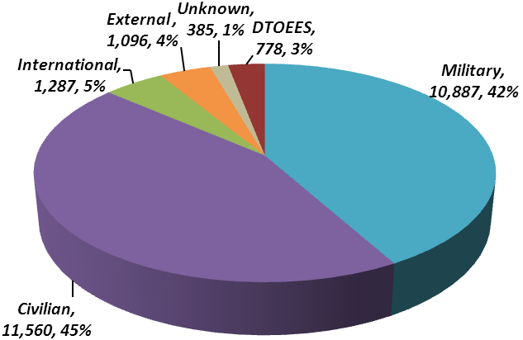
Total Students: 25,993 Total Training Days: 412,326

Figure 4 – F2F Student Numbers, Training Days and percentages of totals by Student Base

- In terms of training days MOD military personnel accounted for 57% of DefAc’s total and civilians for 11%, which is in line with last year’s 64% for military and 13% for civilians. The larger proportion of military student days is explained by attendance on longer courses (e.g. RCDS, JSCSC and DSL). Although training day percentages for each category appear to have fallen slightly this is mainly accounted for by the inclusion this year of DTOEES; broadly they are similar to last year.

- There has been no significant change in the number of International or External students. Improvements in data collection have resulted in a reduction in the totals of completely ‘Unknowns’, students from 4% to 1% and training days from 6% to less than 1%.

DefAc F2F Training by Service
- Figure 5 gives the split of students and training days by service. The total of military Service personnel (10,152 or 39%) is slightly lower than those in figures 4 and 6 as personnel who are known to be military but whose Service was not reported are included in No Service. Of these, 18% came from the Army, 13% from the RAF, with the lowest number (8%) belonging to the RN/RM. This is reflected in the training days, with Army 28%, RAF 12% and RN/RM 11%, although the proportions are different and more in line with the actual split of the 3 services within MOD of 2:1:1.

- This reporting period is the first time that Service data has been collected so no comparison with previous years is possible.

Total Students: 25,993 Total Training Days: 412,326
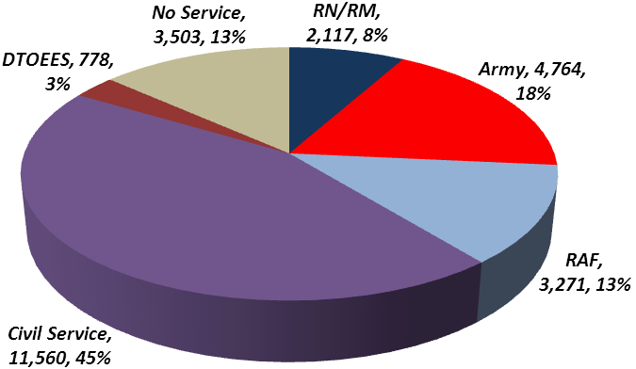
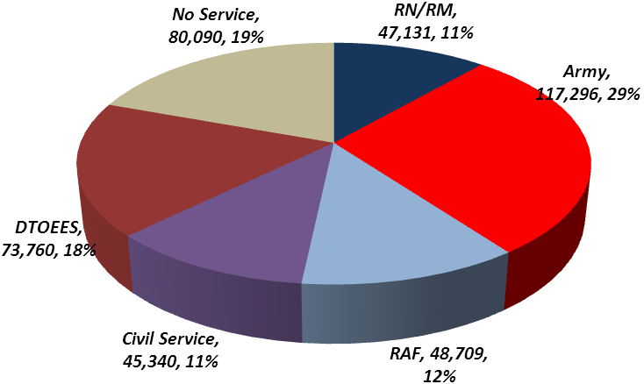

Figure 5 – F2F Student Numbers, Training Days and percentages of totals by Service

DefAc F2F Training by MOD Military Rank and Civilian Grade
- Figure 6 shows that OF3 was once again the most common military rank of student with 2,313, closely followed by OF2 with 2,224. This is the same pattern but slightly down on last year when 2,554 OF3s and 2,268 OF2s received DefAc training. The Other Ranks (OR) total of 2,984 (split as shown in Figure 6) was also down on last year’s 3,743 (when no further split was available).
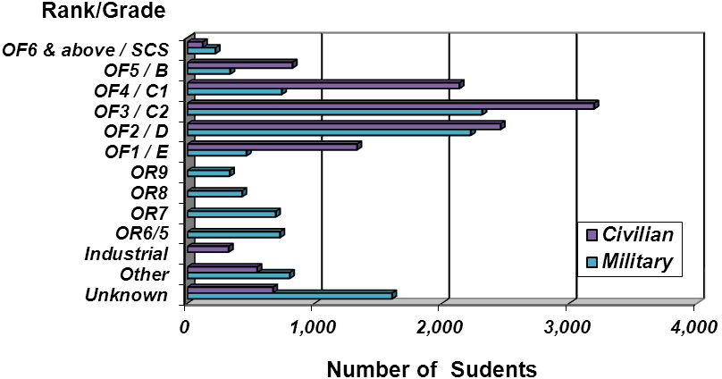
Military Students: 10,887 Civilian Students: 11,560

Figure 6 – F2F Student Numbers by Military Rank and Civilian Grade

- Civilians mirrored this pattern, with the grade of C2 (OF3 equivalent) providing the most civilian students (3,192) and D grades (OF2 equivalent) second with 2,458. As for the military this was the same pattern as last year when 4,914 C2 and 4,036 D grades were trained, although the falls are bigger, in line with the greater overall drop in civilian throughput.

- There was no significant change in the patterns of numbers trained in any of the other categories.

- Almost half (795) of the military unknown category of 1,606 is accounted for by ranks not being entered on to HRMS (used to record CDAT’s Acquisition and CDLM’s Business training). A further 308 unknown ranks were reported by AFCC (see AFCC section) and 480 are due to PG pre-existing enrolments. Almost half (317) of the civilian unknown category of 671 is due to PG pre-existing enrolments with the balance spread throughout other components. Both unknown categories have experienced an improvement in the reporting of ranks and grades.

- Figure 7 shows that, with 40% of all military and 23% of all DefAc training days, the military rank of OF3 received the largest proportion of training in terms of training days. The ranks of OF2 and OF4 came second and third with (respectively) 14% & 13% of all military and 8% & 7% of all DefAc training days. Together these 3 groups accounted for 67% of all military and 38% of all DefAc training days.
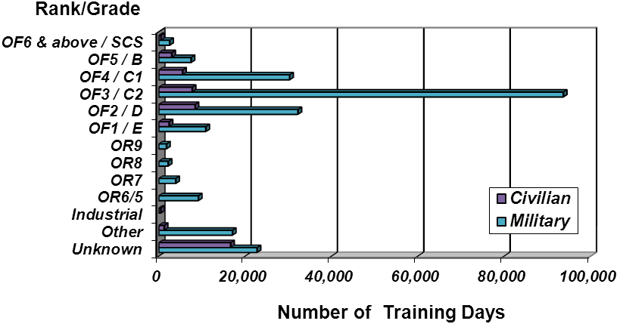
Military Training Days: 233,874 Civilian Training Days: 45,340

Figure 7 – F2F Training Days by Military Rank and Civilian Grade

- Training days for civilians saw D grades top (with 18% of all civilian days), C2 grades a close second (with 17% of civilian days) and C1 grades third (with 12% of civilian days). Together these three groups accounted for just over 5% of all DefAc training days.

Average Cost per Training Day for Financial Year (FY) 2010/11 and 2011/12
- Table 4 gives a high-level overview of the average cost of a training day throughout the DefAc. The costs are calculated using the total number of training days (all types of training) for each component or division and associated gross expenditure during the FY. This expenditure includes a proportion of DefAc HQ costs, apportioned according to the number of training days.

- These figures are included for year-on-year comparison purposes only as they have not been calculated using a comprehensive costing model. A comparison with last year shows that the cost of a training day has risen by 9% across DA-CMT and by an average of 7% across the other colleges; this equates to an average of 8% across the entire Academy.

- Within DA-CMT, A&B courses saw the biggest increase (27%) although the average cost of a training day was the second lowest after DSL. At 17%, Nuclear Department (ND) also experienced a higher than average increase. The DTOEES training day cost went up the least (by 1%) but remained the highest within DA-CMT.

- RCDS and JSCSC saw increases that were in line with the overall DefAc average. AFCC was the only component to experience a fall (of 21%) in cost; in spite of this it retained the highest average training day cost.

- As gross expenditure has fallen slightly across the DefAc the increases outlined above are attributed to the general fall in the total (F2F and non-F2F) number of training days. This would account for A&B’s high percentage rise as it has experienced the greatest fall in the number of training days. ND’s increase is due to both higher expenditure and fewer training days, whereas AFCC’s fall comes from lower expenditure and more training days.

 | FY 10/11 Average Cost per DefAc Training Day
 | Total Gross Expenditure | Gross incl % of HQ costs | Number of All Training Day | Avg Cost per Trg Day
DA-CMT
A&B | 12,946,719 | 19,127,681 | 137,039 | £139.58
Nuclear | 1,912,067 | 2,474,284 | 12,465 | £198.50
DTOEES | 16,021,364 | 19,186,739 | 70,180 | £273.39
Other | 1,730,259 | 1,730,259
AP Contract
LMD | 3,063,758
Tech Div | 4,084,423
HQ/AP Contract | 17,011,387
AP Contract Total | 24,159,567 | 30,078,432 | 131,228 | £229.21
DA-CMT Total | 56,769,975 | 72,597,395 | 350,912 | £206.88
RCDS | 4,532,989 | 5,411,113 | 19,469 | £277.93
AFCC | 1,221,320 | 1,345,040 | 2,743 | £490.35
JSCSC | 45,812,236 | 52,977,361 | 158,859 | £333.49
Non CMT total | 51,566,546 | 59,733,513 | 181,071 | £329.89
DefAc HQ | 23,994,387 | ~
TOTAL DA | 132,330,907 | 132,330,907 | 531,983 | £248.75

 | FY 11/12 Average Cost per DefAc Training Day
 | Total Gross Expenditure | Gross incl % of HQ costs | Number of All Training Days | Avg Cost per Trg Day | Change | % Change
DA-CMT
A&B | 11,314,175 | 15,866,321 | 89,796 | £176.69 | £37.11 | 27%
Nuclear | 2,123,037 | 2,718,188 | 11,740 | £231.53 | £33.03 | 17%
DTOEES | 16,601,818 | 20,341,030 | 73,760 | £275.77 | £2.38 | 1%
DSL | 2,656,830 | 4,213,889 | 30,715 | £137.19 | ~ | ~
AP Contract
LMD | 2,491,914
Tech Div | 4,129,399
HQ/AP Contract | 15,300,764
AP Contract Total | 21,922,077 | 27,388,647 | 107,834 | £253.99 | £24.78 | 11%
DA-CMT Total | 54,617,937 | 70,528,075 | 313,845 | £224.72 | £17.84 | 9%
RCDS | 4,724,535 | 5,703,290 | 19,307 | £295.40 | £17.47 | 6%
AFCC | 997,926 | 1,148,437 | 2,969 | £386.81 | -£103.54 | -21%
JSCSC | 45,306,546 | 52,760,028 | 147,028 | £358.84 | £25.36 | 8%
Non DA-CMT total | 51,029,007 | 59,611,756 | 169,304 | £352.10 | £22.21 | 7%
DefAc HQ | 24,492,887 | ~
TOTAL DA | 130,139,830 | 130,139,830 | 483,149 | £269.36 | £20.61 | 8%
Table 4 – DefAc FY 10/11 and 11/12 Average Costs and comparisons
DEFENCE ACADEMY COMPONENT STATISTICS

RCDS
- RCDS’s aim is to prepare senior officers and officials of the UK and other countries, and future leaders from the private and publics sectors, for high responsibilities in their respective organisations.

- Figure 1 shows that although RCDS trained less than 1% of all DefAc students, its one course delivered 5% of all training days; it also ranks third in DefAc’s top 5 courses ordered by number of F2F training days (Figure 9).

- Table 5 lists the 46 originating countries of this year’s 66 non-UK students. RCDS trained a total of 116 students during the reporting period of which the International category was the largest, providing 57% of all students. 33 MOD military officers, 4 MOD civil servants and 13 external students also attended the course.

Country | Number of students |  | Country |  | Number of Students | Country | Number of Students
Afghanistan | 2 |  | India |  | 5 | Qatar | 2
Algeria | 1 |  | Indonesia |  | 1 | Romania | 2
Australia | 1 |  | Iraq |  | 1 | Saudi Arabia | 2
Austria | 1 |  | Israel |  | 1 | Serbia | 1
Belize | 1 |  | Japan |  | 2 | South Korea | 1
Bosnia-Herzegovina | 1 |  | Jordan |  | 1 | South Sudan | 1
Brazil | 2 |  | Kenya |  | 1 | Sudan | 1
Canada | 2 |  | Kuwait |  | 2 | Turkey | 1
Chile | 1 |  | Morocco |  | 1 | UAE | 2
China | 2 |  | Netherlands |  | 2 | Ukraine | 2
Czech Republic | 1 |  | New Zealand |  | 1 | Uruguay | 1
Estonia | 1 |  | Nigeria |  | 1 | USA | 2
France | 1 |  | Norway |  | 1 | Uzbekistan | 1
Georgia | 1 |  | Oman |  | 1 | Yemen | 1
Germany | 1 |  | Pakistan |  | 4
Hong Kong | 1 |  | Poland |  | 1
Total Countries: |  | 46 |  | Total International Students: |  |  | 66

Table 5 – Originating countries of RCDS International students

- 82 of the 116 total attended all four terms of the RCDS academic year, equating to 16,728 training days. The other 34 attended for various combinations of terms/part-terms making up the balance (2,579) of the total 19,307 training days.

- As table 6 shows, the number of RCDS’ students and associated training days has remained largely unchanged since the previous reporting period, as has its student base.

RCDS | 2010/11 | 2011/12
International | 61 | 66
MOD Military | 36 | 33
MOD Civilian | 3 | 4
External | 15 | 13
Total Students | 115 | 116
Total Training Days | 19,469 | 19,307

Table 6 – RCDS Students and Training Days compared with 2010/11
JSCSC
- As is shown in Figure 1 JSCSC delivered 34% (138,669 days) of training to 10% (2,463) of students during the reporting period, making it the second biggest provider of DefAc training in terms of both days delivered and students. 2,181 military personnel and 14 civilians received training, reflecting its primary role as a provider of training for future commanders and staff officers of the UK Armed Services. Additionally 179 international students and 22 external students, mainly from industry, were trained.

- Based on the number of F2F training days, 4 of the JSCSC’s courses feature in the DefAc’s top 5. The RAF’s JODP is second in DefAc’s list of top 5 courses ordered by number of F2F students. See Figures 9 and 10 for further details.

- The Advanced Command and Staff Course (ACSC) delivered the highest number of JSCSC training days, 58,590, (42%) to 279 (11%) students. The Intermediate Command and Staff Course (Land) (ICSC(L)) was the next highest, delivering 49,800 (36%) training days to 332 (13%) students. The course with the highest number of students was JODP (829 students (34%) totalling 5,885 days (5%)); this number of students contributes significantly to the RAF’s 52% share of JSCSC’s student total.

- There was no change from the previous two years when ACSC and ICSC(L) were first and second in terms of numbers of training days and JODP trained the most students. In all cases there was very little change in the percentages of total students and training days.

- Table 7 shows that the drop in the number of military personnel trained by JSCSC was very similar to its overall fall in the number of students trained, as might be expected when the majority of students are military. The other categories also experienced reductions with the exception of Civilians, which saw a small increase.

Year | Military |  | Civil Service |  | International |  | External |  | Unknown |  | Total
2010/11 | 2,567 |  | 10 |  | 204 |  | 29 |  | 69 |  | 2,879
2011/12 | 2,181 |  | 14 |  | 179 |  | 22 |  | 67 |  | 2,463
% Change |  | 15% |  | 40% |  | 12% |  | 24% |  | 3% |  | 14%
Table 7 – JSCSC F2F Student Base compared with 2010/11

- Table 8 shows that the number of higher ranking military officers (OF5, 6 and above) increased slightly from the previous academic year. However, in line with the overall reductions, fewer students from all the other military ranks were trained by JSCSC. The numbers of students with ranks below OF1 showed the largest drop (of 71%) because the Joint Services Warrant Officers Course did not run.

Year | OF6 |  | OF5 |  | OF4 |  | OF3 |  | OF2 |  | OF1 |  | OR |  | Other |  | Total
2010/11 | 2 |  | 37 |  | 235 |  | 876 |  | 1,016 |  | 235 |  | 166 |  | 312 |  | 2,879
2011/12 | 4 |  | 44 |  | 224 |  | 749 |  | 891 |  | 221 |  | 48 |  | 282 |  | 2,463
% Change |  | 100% |  | 19% |  | 5% |  | 15% |  | 12% |  | 6% |  | 71% |  | 10% |  | 14%
Table 8 – JSCSC F2F Students by rank/grade compared with 2010/11

- See Annex C for more JSCSC charts and further course information.
DA-CMT
- DA-CMT has undergone significant re-organisation since academic year 2010/11 when it comprised Acquisition and Business (A&B) Learning, Leadership & Management Division (LMD), Technology Division (TD) and Nuclear Department (ND). Its current structure is: Centre for Defence Acquisition and Technology (CDAT), Centre for Defence Leadership and Management (CDLM) incorporating Defence School of Languages (DSL), and ND. DTOEES and the PGE programme also fall within its remit. For a more detailed mapping on the realignment of courses please see Annex D.

- Figure 8 shows how the 251,268 training days delivered to 22,355 students were broken down within DA-CMT. With 55% of the total, CDAT trained the most students whilst delivering 17% of training days, due mainly to its high number of shorter courses, particularly within Acquisition. DTOEES on the other hand accounted for the largest proportion of training days (29%) but only 4% of students because of the longer nature of its Defence Sixth Form College (DSFC) training. See table 9 for a breakdown of DTOEES students and training days.

- CDLM trained 31% of total students but almost half of this figure (CDLM (Temp)) relates to non-MOD specific courses. These are gradually being phased out as following the transfer of responsibility for delivery of generic training courses to CSL. In terms of training days however, only 2% of its 25% share belong to this CDLM (Temp) category because these courses are predominantly short (typically one or two days). CDLM’s high number of training days is due mainly to DSL courses which are predominantly longer and can be more than a year in length.

Total Students: 22,355 Total Training Days: 251,268
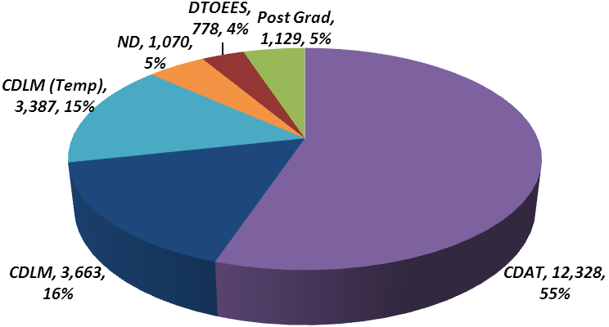
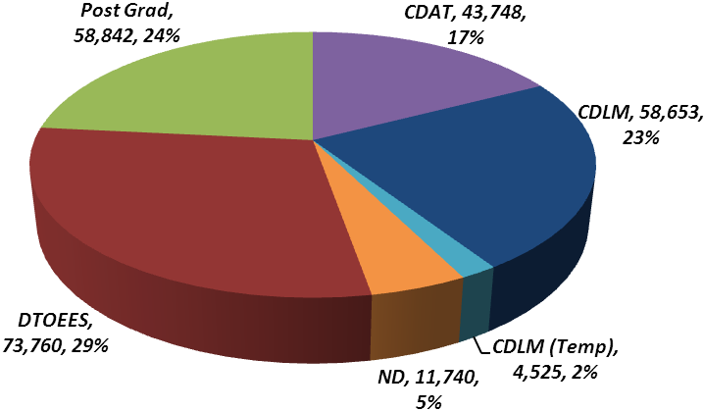

Figure 8 – F2F Student Numbers, Training Days and percentages of totals by Division

- Table 9 shows DA-CMT students and training days in the current and previous reporting periods together with the percentage change between the two periods. Because CDAT and CDLM are new divisions and re-structuring took place during the course of this academic year, only the overall percentage change is shown in table 9 with more detail shown in table 10.

- The number of students trained within ND fell by less than 1% to 1,070, with a bigger drop (of 14%) in the number of training days delivered, possibly due to its longer courses.

- The DTOEES scheme comprises the DSFC and the Defence Technical Undergraduate Scheme (DTUS). DSFC provides a science-based curriculum (delivered via a PFI contract) to students pre-selected as engineer/technical officers in the Armed Forces or as graduate entrants to the MOD Civil Service. This leads to undergraduate/masters study of engineering/technical courses at Partner (and associated) universities.

DA-CMT Division |  | 2010/11 | 2011/12 | % Change
CDAT | Students | See Table 10 (below) | 12,328 |  | ~
CDAT | Training Days | See Table 10 (below) | 43,748 |  | ~
CDLM | Students | See Table 10 (below) | 3,663 |  | ~
CDLM | Training Days | See Table 10 (below) | 58,653 |  | ~
CDLM (Temp) | Students | See Table 10 (below) | 3,387 |  | ~
CDLM (Temp) | Training Days | See Table 10 (below) | 4,525 |  | ~
Sub-total | Students | 28,741 | 19,378 |  | 33%
Sub-total | Training Days | 81,670 | 106,926 |  | 31%
ND | Students | 1,072 | 1,070 |  | <1%
ND | Training Days | 13,617 | 11,740 |  | 14%
PGE | Students | 1,083 | 1,129 |  | 4%
PGE | Training Days | 53,970 | 58,842 |  | 9%
DSFC | Students | 306 | 328 |  | 7%
DSFC | Training Days | 52,020 | 55,760 |  | ~
DTUS | Students | 454 | 450 |  | <1%
DTUS | Training Days | 18,160 | 18,000 |  | ~
DTOEES Sub-Total | Students | 760 | 778 |  | 4%
DTOEES Sub-Total | Training Days | 70,180 | 73,760 |  | 9%
DA-CMT Totals | Students | 31,656 | 22,355 |  | 29%
DA-CMT Totals | Training Days | 219,437 | 251,268 |  | 15%

Table 9 – DA-CMT F2F Students and Training Days by Division compared with 2010/11

- See table 15 for more details relating to PGE enrolments.

- Table 10 shows that training by the DA-CMT divisions that now comprise CDAT and CDLM has decreased by about a third in terms of students but increased by nearly the same amount in terms of training days. The overall increase in training days is due to the inclusion of DSL.

- Acquisition courses (now within CDAT) experienced reductions of more than a quarter in both students and training days, attributed to the increased importance of the blended approach, financial constraints on T&S and MOD civilians leaving on early release.

DA-CMT Division |  | 2010/11 | 2011/12 | % Change
A&B (Acquisition) | Students | 9,585 | 6,870 |  | 28%
A&B (Acquisition) | Training Days | 17,994 | 13,164 |  | 27%
A&B (Business) | Students | 13,155 | 6,760 |  | 49 %
A&B (Business) | Training Days | 25,165 | 11,055 |  | 56 %
LMD | Students | 2,535 | 2,522 |  | <1%
LMD | Training Days | 11,698 | 11,729 |  | <1%
DSL | Students | - | 470 |  | NEW
DSL | Training Days | - | 46,072 |  | NEW
TD | Students | 3,466 | 2,756 |  | 20%
TD | Training Days | 26,813 | 24,906 |  | 7%
Totals | Students | 28,741 | 19,378 |  | 33%
Totals | Training Days | 81,670 | 106,926 |  | 31%

Table 10 – F2F Students and Training Days by old DA-CMT division for comparison with 2010/11

- Table 10 also shows that the former Business area saw the biggest overall reductions of about half. This was mainly due to the continued phasing out of Business courses (to CSL); attendance on these courses dropped by approximately two thirds as shown in table 11.

Year | 2010/11 | 2011/12 | Change |  | % Change
Students | 9,057 | 3,387 |  | 5,670 |  | 63%
Training Days | 13,298 | 4,525 |  | 8,773 |  | 66%

Table 11 – DA-CMT ex-Business (CDLM ‘temporary’) students and training days compared with 2010/11

- Attendance on the seven remaining Defence-specific leadership and management courses (that CDLM will continue to deliver) have also decreased, but by smaller amounts, as shown in table 12.

Year | 2010/11 | 2011/12 | Change |  | % Change
Students | 1,150 | 893 |  | 257 |  | 22%
Training Days | 2,758 | 1,827 |  | 931 |  | 33%

Table 12 – DA-CMT ex-Business (CDLM) students and training days compared with 2010/11

- The former LMD courses, which are also part of the CDLM portfolio, saw little change. Within this area, the courses run by the Joint Equality and Diversity Training Centre (JEDTC) saw increases as shown in table 13.

Year | 2010/11 | 2011/12 | Change |  | % Change
Students | 1,252 | 1,322 |  | 70 |  | 6%
Training Days | 4,782 | 5,132 |  | 350 |  | 7%

Table 13 – DA-CMT ex-LMD JEDTC (CDLM) students and training days compared with 2010/11

- Technology courses (Ex-TD, now part of the CDAT portfolio) lost 20% of students and 7% of training days. Within this area, the Information Management (IM) Branch courses saw the following small increase in the number of students trained with a smaller than average decrease in the number of training days (as shown in table 14). This is due to the introduction of the 2 day Records Management Course offsetting slightly reduced attendance on the 5 day Information Manager and Information Support Officer courses.

Year | 2010/11 | 2011/12 | Change |  | % Change
Students | 970 | 985 |  | 15 |  | 2%
Training Days | 4,277 | 4,130 |  | 147 |  | 3%

Table 14 – DA-CMT CDAT IM students and training days compared with 2010/11

- Table 15 shows that the number of students enrolling on all PG programmes increased by 12% this reporting period. Student intake on full-time MScs and enrolments on part-time MScs have increased by 31% and 39% respectively. However, the Executive programme intake has fallen by 10%.

Programme |  | 2010/11 | 2011/12 | % Change
Full-time  MScs | Student intake | 52 | 68 |  | 31%
Full-time  MScs | Training Days | 10,920 | 14,280 | -
Part-time MScs | Student intake | 46 | 64 |  | 39%
Part-time MScs | Training Days | 1,932 |  | -
Executive  MScs | Student intake | 101 | 91 |  | 10%
Executive  MScs | Training Days | 4,242 |  | -
Intake totals | Student intake | 199 | 223 |  | 12%
Existing  enrolments | Students | ~878 | ~900 | -
Existing  enrolments | Training Days | ~36,876 | ~37,800 | -
MPhil/PhD | Students | 6 | 6 | -
MPhil/PhD | Training Days | 252 | 252 | -
Programme Totals | Students | 1,083 | 1,129 |  | 4%
Programme Totals | Training Days | 53,970 | 58,842 |  | 9%

Table 15 – HQ-managed Post-Graduate (PG) Programme Summary

- The increase in full-time students was due to an additional 6 MOD and 10 overseas students. The part-time increase was due to the modularisation of the ICM MSc in Contract Year (CY) 6. The addition of the MAA MSc to the Academic Provider (AP) contract at the end of CY5 also contributed to the increase in part-time students.

- The fall in the Executive programme intake is largely due to the Defence Acquisition Management AIA PG Certificate being removed from the AP contract at the end of CY5. This meant that there was no new intake in Jan 12.

- Further details of the 2011/12 PG programme are included at Annex A.

DA-CMT F2F Training by MOD Military Rank and Civilian Grade
- Table 16 shows that DA-CMT followed the DefAc trend with the ranks of OF3 and OF2 providing the most students as last year. DA-CMT also saw a slight fall in the number of OF3s but a 12% increase in the number of OF2s.

Military
Rank | 2010/2011 | 2011/2012 | % Change
OF6 & above | 250 | 201 |  | 20%
OF5 | 305 | 272 |  | 11%
OF4 | 563 | 499 |  | 11%
OF3 | 1,522 | 1,502 |  | 1%
OF2 | 1,071 | 1,205 |  | 12%
OF1 | 158 | 227 |  | 44%
OR9 | ~ | 291 |  | ~
OR8 | ~ | 346 |  | ~
OR7 | ~ | 590 |  | ~
OR6/5 | ~ | 582 |  | ~
OR4-1 | ~ | 754 |  | ~
Total Other | 3,079 | 2,563 |  | 17%
Unknown | 1,106 | 1,298 |  | 17%
Total | 8,054 | 7,767 |  | 4%

Table 16 – DA-CMT F2F Military Students by Rank compared with 2010/11

- All the other categories provided fewer students except for the unknown category which increased. This is mainly due to the inclusion of existing enrolments for PG military whose ranks have not previously been captured. Again in line with the overall DefAc picture, the total number of military students has fallen by less than the total number of civilians.

- Table 17 shows that DA-CMT also mirrored the DefAc trend for civilians, with the grade of C2 (OF3 equivalent) and D (OF2 equivalent) providing the most students as they did last year. However, the numbers of both these grades dropped; the 39% total fall in civilians trained was spread evenly across all grades. The bigger fall in civilian training within DA-CMT was due to factors already outlined such as courses being phased out to CSL, restrictions in T&S and early release.

Civilian
Grade | 2010/2011 | 2011/2012 | % Change
SCS | 189 | 119 |  | 37%
B | 1,216 | 822 |  | 32%
C1 | 3,375 | 2,135 |  | 37%
C2 | 4,912 | 3,192 |  | 35%
D | 4,029 | 2,458 |  | 39%
E | 2,484 | 1,321 |  | 47%
Industrial | 557 | 323 |  | 42%
Other Civilian | 1,138 | 539 |  | 53%
Unknown | 1,069 | 583 |  | 45%
Total | 18,969 | 11,492 |  | 39%

Table 17 – DA-CMT F2F Civilian Students by Grade compared with 2010/11

- The biggest changes in table 18 are the increase in the number of International students and the fall in the number of unknowns. Most of the International students were reported by CDLM, with 653 (63%) having been trained abroad on its expeditionary courses and a further 146 (14%) trained by DSL on its English language courses. The fall in (completely) unknowns is once again a positive step in terms of data reported.

Other
Grade | 2010/2011 | 2011/2012 | % Change
International | 743 | 1,042 |  | 40%
External | 1,172 | 1,002 |  | 15%
DTOEES | 760 | 778 |  | 2%
Unknown | 875 | 274 |  | 69%
Total | 3,550 | 3,096 |  | 13%
Post-Graduate | 1,083 | (incl in Ranks/Grades) |  | ~
Total | 4,633 | 3,096

Table 18 – DA-CMT F2F Non-MOD Students compared with 2010/11
AFCC
- As figure 1 shows, AFCC’s percentage of DefAc students was 4% (1,059) during this reporting period, equating to less than 1% (3,082) of training days. Its students comprised 906 military personnel and 50 civilians, giving a military to civilian ratio of 18:1, the same as last year. The high proportion of military is due to AFCC’s primary role being to train chaplains in the Armed Forces; its pastoral support courses are also aimed at the Armed Forces. A further 59 external and 44 unknown students were reported.

- During the academic year AFCC reported 16 different courses in support of its business remit to deliver pastoral, spiritual and initial chaplaincy training. See Annex E for more detail on courses delivered.

- The course with the highest number of students and training days was Visiting Officer Skills. This course saw 822 days delivered to 274 students attending 11 occurrences, an increase from the 663 training days delivered to 221 students during 2010/11. The Listening Skills Workshop was second with 406 training days delivered to 203 students over 13 occurrences, again more than the 328 days delivered to 164 students the previous year.

AFCC F2F Students by MOD Military Rank
- The military comprised 86% of all AFCC students (against last year’s 89%) and has increased by 19% from last year. Table 19 shows that the largest category within this group was again ‘Other Ranks’, with 373 (41%) of the total military, slightly up on last year’s 39%. Of the named ranks, OF2 and OF3 were the largest categories with 128 and 62 students respectively, although OF3 showing a substantial drop of 44% from last year. These 3 groups made up 62% of its military total.

Year | OF6 | OF5 |  | OF4 | OF3 |  | OF2 |  | OF1 |  | Other Ranks |  | Unknown |  | Total
2010/11 | 2 | 6 |  | 15 | 112 |  | 133 |  | 4 |  | 298 |  | 194 |  | 764
2011/12 | 2 | 2 |  | 15 | 62 |  | 128 |  | 16 |  | 373 |  | 308 |  | 906
% Change | ~ |  | 66% | ~ |  | 44% |  | 4% |  | >100% |  | 25% |  | 59% |  | 19%

Table 19 – AFCC Military F2F Students by Rank compared with 2010/11

- AFCC had a large percentage of unknown ranks, with one third of the military falling into this category. There are a number of reasons for this, e.g. RN chaplains not having recognised ranks and the AFCC ‘rank-less’ training culture both contribute.
DefAc Courses with highest number of F2F training Days
- Figure 9 shows the five courses that deliver the highest number of training days within the DefAc. Together these courses contribute over half (51%) of the total number of training days (excluding PGE and DTOEES). Four out of the five courses are run by JSCSC; the other is RCDS’ long course.

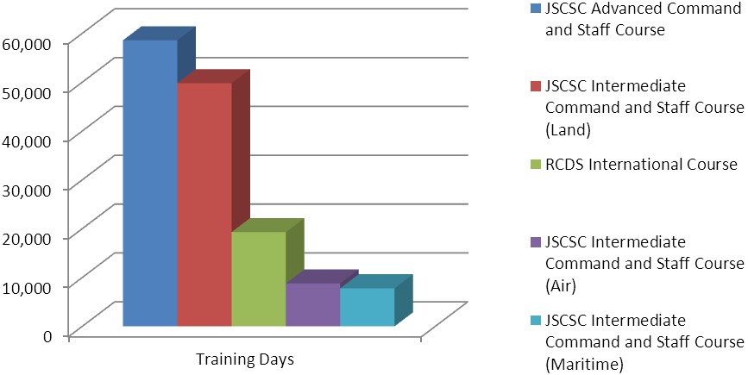

Figure 9 – Top 5 DefAc courses ordered by F2F Training Day

- See Annex F for the top twenty courses by F2F Training Day.

DefAc Courses with highest number of F2F Students
- Figure 10 shows the five courses that train the highest number of students²⁶ within the DefAc. Together these courses make up almost 19% of the total number of students. Four of the five are run by DA-CMT with the other one belonging to JSCSC. However, two of the four DA-CMT courses (with nearly half of the ‘top five’ students) are ‘temporary’ generic CDLM courses that are being phased out (due to CSL).
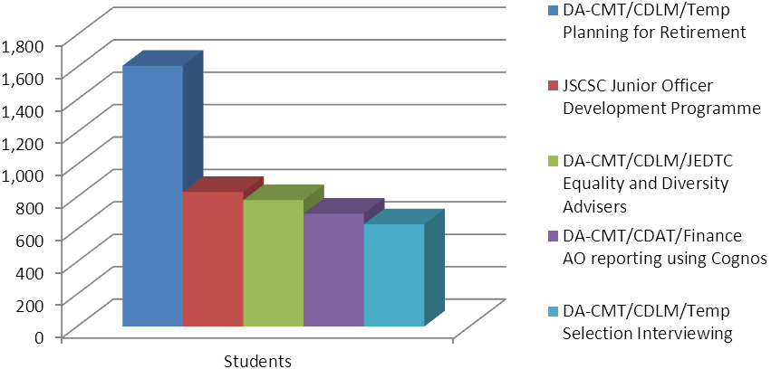

Figure 10 – Top 5 DefAc courses ordered by F2F Students

- See Annex G for the top twenty courses by F2F Student Number.
DefAc Courses with the lowest number of F2F Training Days
- Figure 11 shows the five courses that deliver the lowest number of training days within the DefAc. All five belong to DA-CMT, with one in the CDLM ‘temporary’ category.

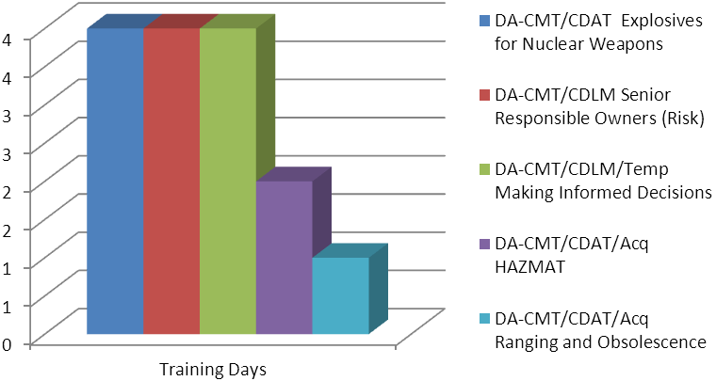

Figure 11 – DefAc courses with lowest number of F2F Training Days

- See Annex H for a list of the 136 DefAc courses that between them contribute less than 1% of the total number of training days.

General Trends
- In conclusion, during the academic year 2011/12, i.e. between 1 Sep 11 and 31 Aug 12:

F2F training:
  - DefAc F2F training totalled 25,993 students over 412,326 days; 27% fewer students but 6% more training days since last academic year. The downward trend in students was a continuation of last year’s reported 29% fall; the 6% increase in training days reversed last year’s 7% fall.

  - Within DefAc, DA-CMT once again decreased the most with 29% less students, (from last year’s 33%). DA-CMT also contributed the most to DefAc’s 6% increase in training days, with 15% more (reversing its 14% decrease from last year).

  - As last year, DA-CMT trained the largest proportion of students (86%) and delivered the highest percentage of training days (61%), a decrease in students (from 89%) but an increased share of training days (from 56%).

  - The number of students enrolling on HQ-managed PG programmes has continued its upward trend, from 8% last year to 12% this. Both the full and part-time intakes increased (by 31% and 39% respectively); only the Executive programme fell by 10%.

  - DE&S remained DefAc’s primary customer in terms of student numbers, again providing around 32%. DE&S was also DA-CMT’s primary customer, with no students from this TLB reported by any of the other components. DefAc’s primary customer in terms of training days remained Army Command, with 22% of training delivered.

  - Military OF3 and its civilian equivalent of C2 continued to be the most trained rank and grade, unchanged from last year.

  - The proportion of civilian students dropped from last year’s 54% to 45%, whilst military increased from 36% to 42%, a direct result of the loss of DA-CMT’s generic leadership and management courses which were predominantly attended by civilians.

  - DA-CMT once again trained over 99% of the civilians who attended DefAc courses, demonstrating the military focus of the other components (particularly JSCSC and AFCC).

Non F2F training:
  - DefAc non-F2F training fell by 45% (to 80,473 students) and by 36% (to 63,711 ETDs), due mainly to a down-turn in the Business e-Learning (estimated at 50%).

All training:
  - All DefAc training totalled 106,466 students over 476,037 training days, falls of 41% and 3% respectively.

ANNEXES:

- HQ managed Postgraduate statistics by course
- RCDS charts
- Diagrams by Student Base, Service and Rank/Grade
- JSCSC charts
- Diagrams by TLB, Student Base/Service and Rank/Grade
- JSCSC lists of courses by Training Days/Students
- DA-CMT charts
- Diagrams by TLB, Student Base, Service and Rank/Grade
- Course mapping across restructured DA-CMT Divisions
- Courses by F2F Training Days and Students
- AFCC charts
- Diagrams by Student Base/Service and Rank/Grade
- AFCC lists of courses by Training Days/Students
- DefAc Top twenty courses by F2F Training Days and Students
- DefAc Training that contributes < 1% of F2F Training Days

Annex A to DefAc T&E Statistical Analysis
Report dated 14 Jan 2013

Annex A – HQ POSTGRADUATE PROGRAMMES TAKE-UP AND TRAINING DAYS BY COURSE
AY 2011/12 Programme | No of students enrolled | Training Days
Full-time MScs (Sep 11 intake)
Explosives Ordnance Engineering | 18 | 3,780
Guided Weapons Systems | 10 | 2,100
Information Capability Management | 15 | 3,150
Master in Business Administration | 6 | 1,260
Mechanical Electrical Systems Engineering | 15 | 3,150
Systems Engineering for Defence Capability – PG Cert | 4 | 840
Full-time Total | 68 | 14,280
Part-time MScs (Sep 11 intake)
Explosives Ordnance Engineering | 2 | 84
Information Capability Management | 8 | 336
Systems Engineering for Defence Capability | 8 | 336
Mechanical Electrical Systems Engineering – PG Cert | 2 | 84
Military Aerospace & Airworthiness (incl. PG Cert) | 19 | 798
Part-time Sep 11 Total | 39 | 1,638
Part-time MScs (Jan 12 intake)
Information Capability Management | 19 | 798
Systems Engineering for Defence Capability | 6 | 252
Part-time Jan 12 Total | 25 | 1,050
Executive MScs (Jan 12 intake)
Defence Acquisition Management | 28 | 1,176
Defence Leadership Studies | 20 | 840
Master in Business Administration (Defence) | 13 | 546
Programme & Project Management | 30 | 1,260
Executive Total | 91 | 3,822
Pre-2011 students enrolled on the Part-Time/ Executive MScs & the Modular Masters Programme (MMP) | ~900 | ~37,800
MPhil/PhD | 6 | 252
Overall Total | 1,129 | 58,842

Annex B to DefAc T&E Statistical Analysis
Report dated 14 Jan 2013
Annex B - RCDS F2F charts

Training by Student Base Training by Service
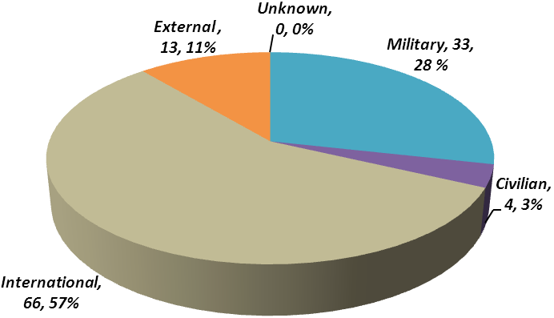
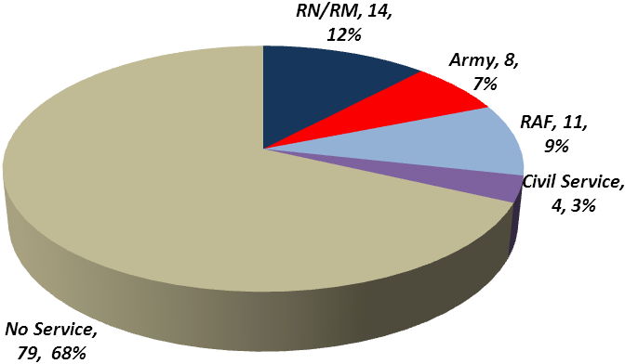
Total Students: 116

Training by Rank/Grade
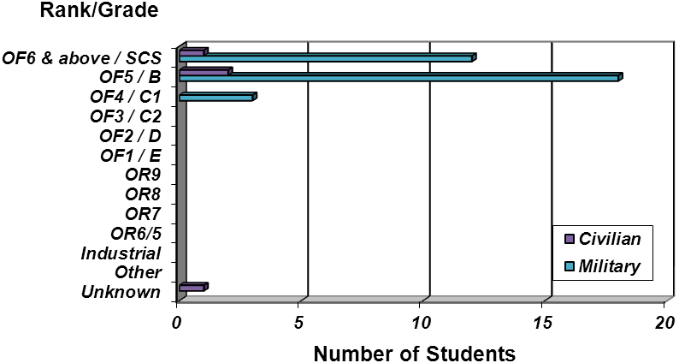
Military Students: 33 Civilian Students: 4

Annex C to DefAc T&E Statistical Analysis
Report dated 14 Jan 2013
Annex C - JSCSC F2F charts

Training by TLB
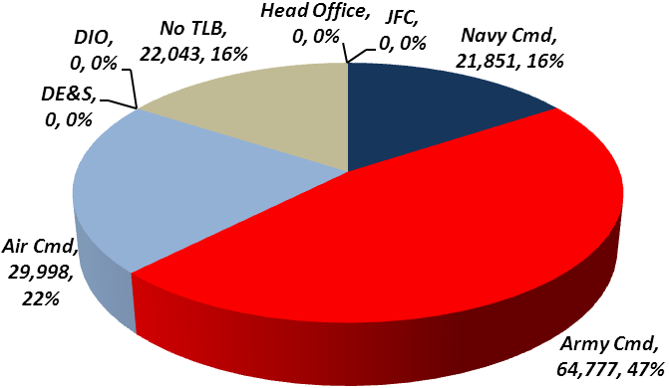
Total Students: 2,463 Total Training Days: 138,669
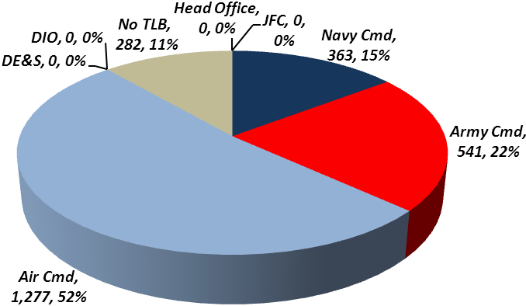

Training by Student Base/Service
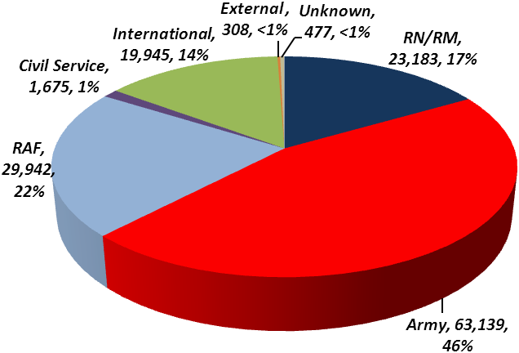
Total Students: 2,463 Total Training Days: 138,669
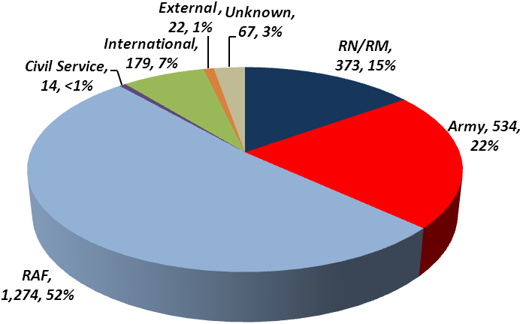

Training by Rank/Grade
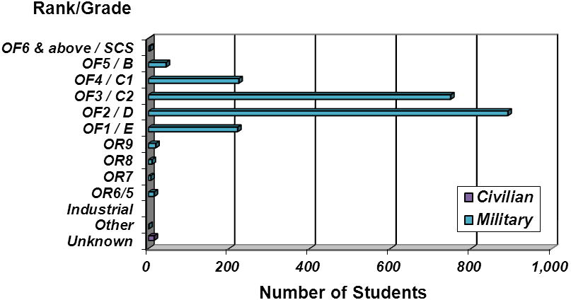
Total Military Students: 2, 181 Total Civilian Students: 14
Annex C to DefAc T&E Statistical Analysis
Report dated 14 Jan 2013
JSCSC Courses by F2F Training Days
Course Title | Duration | Training Days | % of Total
Advanced Command and Staff Course | 210 | 58,590 | 42.25%
Intermediate Command and Staff Course (Land) | 150 | 49,800 | 35.91%
Intermediate Command and Staff Course (Air) | 40 | 8,800 | 6.35%
Intermediate Command and Staff Course (Maritime) | 40 | 7,800 | 5.62%
Junior Officer Development Programme | 5/10 | 5,885 | 4.24%
Higher Command and Staff Course | 80 | 2,640 | 1.90%
Pre-Course Training for International Students | 15 | 1,335 | 0.96%
Advanced Command and Staff Course (Reserves) | 12 | 996 | 0.72%
Territorial Army Initial Staff Course | 11 | 737 | 0.53%
RAF Community Support Course | 5 | 420 | 0.30%
Intermediate Command and Staff Course (Maritime Reserves) | 12 | 372 | 0.27%
Advanced Command and Staff Course - DP&SP Module | 14 | 308 | 0.22%
Future Commanders Study Period | 5 | 295 | 0.21%
RM Advanced Amphibious Warfare Course | 20 | 240 | 0.17%
Intermediate Command and Staff Course (Air Reserves) | 15 | 150 | 0.11%
UK Service Attaches Course | 3 | 102 | 0.07%
Royal Navy Reserve Media Operations Course | 3 | 88 | 0.06%
Armed Forces Parliamentary Scheme - Introduction to Defence Policy | 3 | 65 | 0.05%
Briefings for British Students Attending Overseas Staff Colleges | 2 | 24 | 0.02%
Senior Executives Partners Seminar | 2 | 22 | 0.02%

JSCSC Courses by F2F Students Numbers
Course Title | Duration | Students | % of Total
Junior Officer Development Programme | 5/10 | 829 | 33.66%
Intermediate Command and Staff Course (Land) | 150 | 332 | 13.48%
Advanced Command and Staff Course | 210 | 279 | 11.33%
Intermediate Command and Staff Course (Air) | 40 | 220 | 8.93%
Intermediate Command and Staff Course (Maritime) | 40 | 195 | 7.92%
Pre-Course Training for International Students | 15 | 89 | 3.61%
RAF Community Support Course | 5 | 84 | 3.41%
Advanced Command and Staff Course (Reserves) | 12 | 83 | 3.37%
Territorial Army Initial Staff Course | 11 | 67 | 2.72%
Future Commanders Study Period | 5 | 59 | 2.40%
Royal Navy Reserve Media Operations Course | 3 | 35 | 1.42%
UK Service Attaches Course | 3 | 34 | 1.38%
Higher Command and Staff Course | 80 | 33 | 1.34%
Intermediate Command and Staff Course (Maritime Reserves) | 12 | 31 | 1.26%
Armed Forces Parliamentary Scheme - Introduction to Defence Policy | 3 | 26 | 1.06%
Advanced Command and Staff Course - DP&SP Module | 14 | 22 | 0.89%
RM Advanced Amphibious Warfare Course | 20 | 12 | 0.49%
Briefings for British Students Attending Overseas Staff Colleges | 2 | 12 | 0.49%
Senior Executives Partners Seminar | 2 | 11 | 0.45%
Intermediate Command and Staff Course (Air Reserves) | 15 | 10 | 0.41%

Annex D to DefAc T&E Statistical Analysis
Report dated 14 Jan 2013
Annex D – DA-CMT F2F Charts

Training by TLB
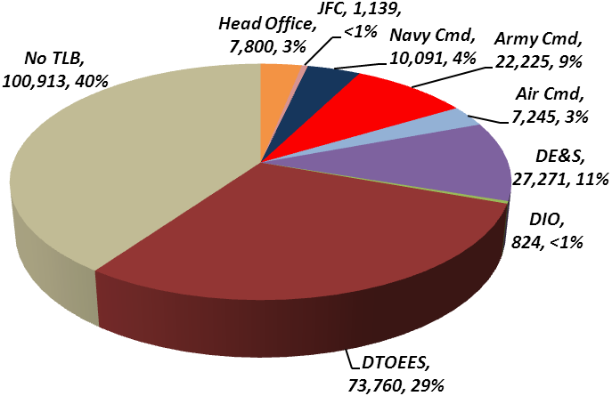
Total Students: 22,355 Total Training Days: 251,268
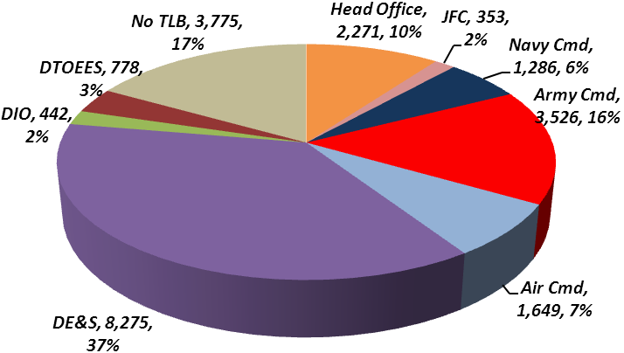

Training by Student Base
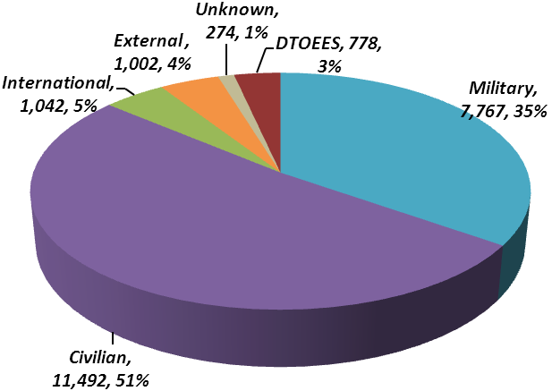
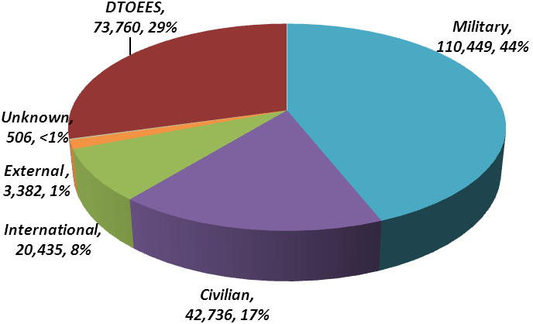
Total Students: 22,355 Total Training Days: 251,268

Training by Service
Total Students: 22,355 Total Training Days: 251,268
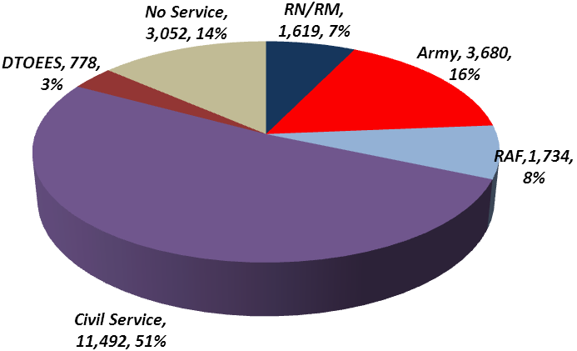
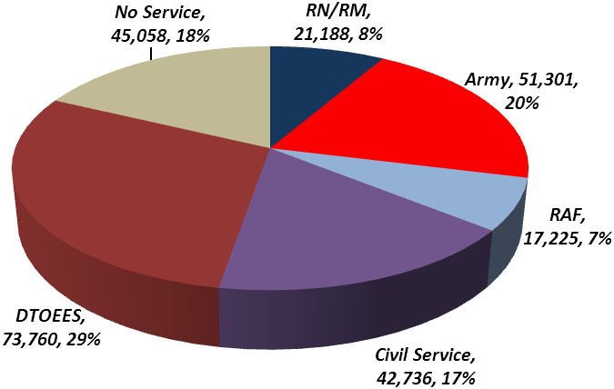
Annex D to DefAc T&E Statistical Analysis
Report dated 14 Jan 2013

Training by Rank/Grade
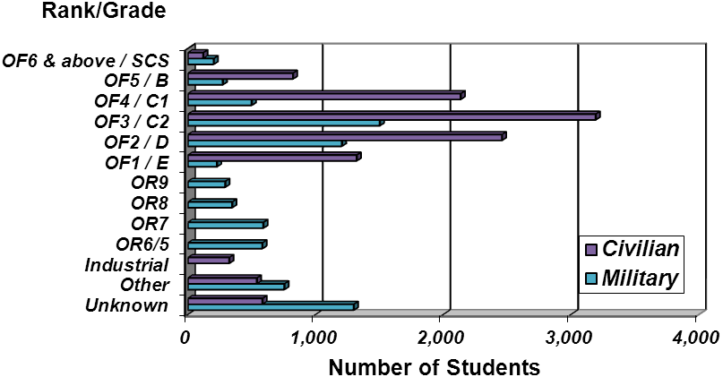
Total Military Students: 7,767 Total Civilian Students: 11,492

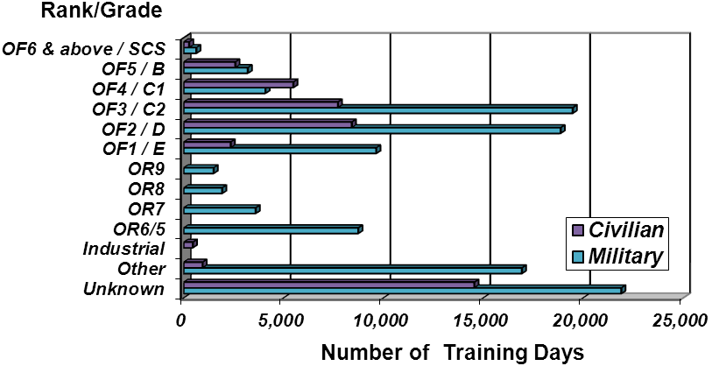
Total Military Training Days: 110,449 Total Civilian Training Days: 42,736

Annex D to DefAc T&E Statistical Analysis
Report dated 14 Jan 2013

Course mapping across restructured DA-CMT Divisions

2011/12 | 2010/11
CDAT | A&B Acquisition courses
CDAT | TD Technology courses
CDAT | A&B Business AFT courses
CDAT | A&B Business Finance courses
CDAT | LMD Strategic courses
CDLM | LMD other (incl. JEDTC and expeditionary) courses
CDLM | DSL courses
CDLM | A&B Business Defence specific courses
CDLM (Temp) | A&B Business generic courses (transferring to CSL)
ND | ND (no change)

DA-CMT Top Twenty Courses by F2F Training Days
Division | Course Title | Duration | Students | Training Days | % of Trg Days
CDLM/JEDTC | Equality and Diversity Advisers | 5 | 779 | 3,895 | 2.356%
CDLM | Export Managing Defence in the Wider Security Context | 5/7/9/10/12/35 | 276 | 3,199 | 1.935%
CDAT | Battlespace Technology MSc | 74 | 40 | 2,960 | 1.790%
CDAT | Acquisition Employment Training | 25 | 144 | 2,940 | 1.778%
ND | Nuclear Reactor Course (PgD in Nuclear Reactor Technology) | 125 | 22 | 2,750 | 1.663%
CDLM/DSL | Pashto Professional (Jt Cap) | 220 | 12 | 2,640 | 1.597%
CDLM/DSL | Pashto Ops 3.3 | 219 | 12 | 2,628 | 1.589%
CDLM/DSL | Pashto Ops 4.4 | 230 | 11 | 2,530 | 1.530%
CDLM/DSL | Dari Professional Jt Cap Ops | 220 | 11 | 2,420 | 1.464%
CDLM/DSL | Pashto Professional (Jt Cap) | 220 | 11 | 2,420 | 1.464%
CDLM/DSL | Pashto Ops 3.3 | 219 | 11 | 2,409 | 1.457%
CDAT | Ammunition Technical Officers | 110 | 19 | 2,090 | 1.264%
CDAT | Information Support Officers | 5 | 390 | 1,950 | 1.179%
ND | Nuclear Advance Course (MSc) | 225 | 8 | 1,800 | 1.089%
CDLM/DSL | Arabic professional | 149 | 12 | 1,788 | 1.081%
CDLM/DSL | Dari Ops 3.3 | 219 | 8 | 1,752 | 1.060%
CDAT | Ammunition Technicians | 25 | 69 | 1,725 | 1.043%
CDAT | Information Managers | 5 | 330 | 1,650 | 0.998
ND | Nuclear General Course | 35 | 46 | 1,610 | 0.974%
CDLM/Temp | Planning for Retirement | 1 | 1,608 | 1,608 | 0.973%

Annex D to DefAc T&E Statistical Analysis
Report dated 14 Jan 2013
DA-CMT Top Twenty Courses by F2F Students
Division | Title | Duration | Training Days | Students | % of Students
CDLM/Temp | Planning for Retirement | 1 | 1,608 | 1,608 | 7.852%
CDLM/JEDTC | Equality and Diversity Advisers | 5 | 3,895 | 779 | 3.804%
CDAT/Finance | AO reporting using Cognos | 1 | 696 | 696 | 3.399%
CDLM/Temp | Selection Interviewing | 1/2 | 1,255 | 630 | 3.076%
CDAT/Acq | Project Management Tools | 2/3 | 1,042 | 435 | 2.124%
CDAT/Acq | Risk Management Principles | 1/2 | 658 | 408 | 1.992%
CDAT | Information Support Officers | 5 | 1,950 | 390 | 1.904%
CDAT/Acq | APMP EXAM | 0.5 | 175 | 349 | 1.704%
CDAT | Information Managers | 5 | 1,650 | 330 | 1.611%
CDLM/JEDTC | Assistant Equality and Diversity Advisers | 3 | 858 | 286 | 1.397%
CDAT/Acq | Lean Fundamentals | 2/3 | 801 | 286 | 1.397%
CDLM | Managing Civilian Staff | 1 | 283 | 283 | 1.382%
CDLM | Export Managing Defence in the Wider Security Context | 5/7/9/10/12/35 | 3,199 | 276 | 1.348%
ND | Workplace Supervisors (Radiation Material) | 2 | 488 | 244 | 1.191%
CDLM | Export Strategic Leadership Programme | 1/4/5 | 900 | 237 | 1.157%
CDAT/Acq | System Safety In Action | 2 | 468 | 234 | 1.143%
CDAT/Acq | Intro to Defence Acquisition | 1/2 | 358 | 227 | 1.108%
CDAT/Acq | Mat & Fin Accounting Basic | 1 | 227 | 227 | 1.108%
CDAT/Acq | APMP Exam Preparation | 2 | 426 | 213 | 1.040%
CDAT/Acq | Mat & Fin Accounting Advanced | 1 | 201 | 201 | 0.981%

DA-CMT Bottom Twenty Courses by F2F Training Days
Division | Course Title | Duration | Students | Training Days | % of Trg Days
CDAT/AFT | F2 Resit Revision | 2 | 3 | 6 | 0.005%
CDAT | Explosives and the Environment | 3 | 2 | 6 | 0.005%
CDAT | Electromagnetic Propagation Antennas and Devices | 5 | 1 | 5 | 0.004%
CDAT | Electro-Optics & IR Sensors 1 | 5 | 1 | 5 | 0.004%
CDAT | Information Knowledge Management | 5 | 1 | 5 | 0.004%
CDAT | Foundations of IS | 5 | 1 | 5 | 0.004%
CDAT | Aircraft Survivability (MAA07) | 5 | 1 | 5 | 0.004%
CDAT | Design, Durability and Integrity of Composite Aircraft Structures (MAA08) | 5 | 1 | 5 | 0.004%
CDAT | Introduction to Aircraft Structural Crashworthiness (MAA12) | 5 | 1 | 5 | 0.004%
CDAT | Radar Electronic Warfare | 5 | 1 | 5 | 0.004%
CDAT | Radar Principles | 5 | 1 | 5 | 0.004%
CDAT | Systems Engineering Lifecycle Processes | 5 | 1 | 5 | 0.004%
CDLM | Senior Responsible Owner (Benefits) | 1 | 5 | 5 | 0.004%
CDAT/AFT | P2 Resit Revision | 2 | 2 | 4 | 0.003%
CDAT | Computer Modelling Tools in EOE | 2 | 2 | 4 | 0.003%
CDAT | Explosives for Nuclear Weapons | 4 | 1 | 4 | 0.003%
CDLM | Senior Responsible Owners (Risk) | 1 | 4 | 4 | 0.003%
CDLM/Temp | Making Informed Decisions | 1 | 4 | 4 | 0.003%
CDAT/Acq | HAZMAT | 0.5 | 4 | 2 | 0.002%
CDAT/Acq | Ranging and Obsolescence | 1 | 1 | 1 | 0.001%
Annex E to DefAc T&E Statistical Analysis
Report dated 14 Jan 2013

Annex E – AFCC Charts

Total Students: 1,059

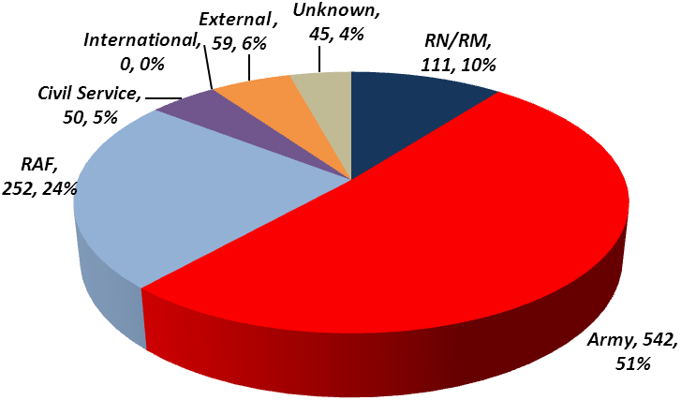
Training by TLB Training by Student Base/ Service
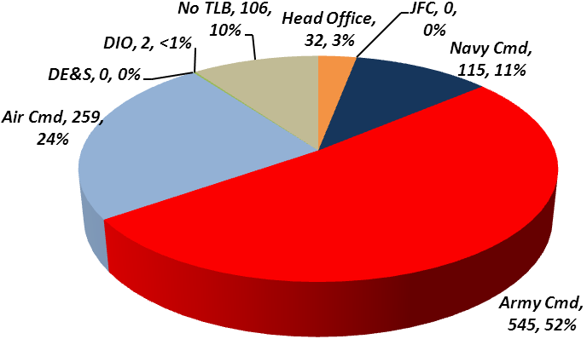

Training by Rank/Grade

Total Military Students: 906 Total Civilian Students: 50
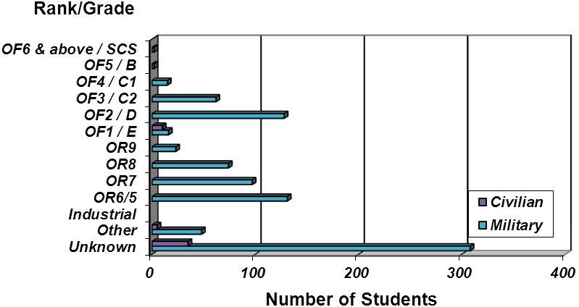

Annex E to DefAc T&E Statistical Analysis
Report dated 14 Jan 2013

AFCC Courses by F2F Training Days
Course Title | Duration | Students | Training Days | % of Trg Days
Visiting Officers Skills | 3 | 274 | 822 | 26.67%
Listening Skills Workshop | 2 | 203 | 406 | 13.17%
Continuing Ministerial Education | 2 | 145 | 290 | 9.41%
Bereavement & Loss Workshop | 3 | 83 | 249 | 8.08%
ATC Personal Awareness | 3 | 80 | 240 | 7.79%
Army Chaplaincy CPD | 2/3 | 100 | 219 | 7.11%
Regular Army Chaplaincy Initial Training | 30 | 7 | 210 | 6.81%
RN CPD | 4/5 | 35 | 169 | 5.48%
Army Chaplaincy Initial Training | 5/11/21 | 17 | 151 | 4.90%
United Board Conference | 3 | 27 | 81 | 2.63%
Tri-Service Methodist Conference | 3 | 26 | 78 | 2.53%
CSPCI Conference | 3 | 23 | 69 | 2.24%
RAF Chaplains Pre-Deployment Training | 2 | 23 | 46 | 1.49%
RAF Chaplains Induction Training | 5 | 5 | 25 | 0.81%
CF3 Army Chaplaincy Leadership | 3 | 5 | 15 | 0.49%
CF2 Army Chaplaincy Leadership | 2 | 6 | 12 | 0.39%

AFCC Courses by F2F Students Numbers
Course Title | Duration | Training Days | Students | % of Students
Visiting Officers Skills | 3 | 822 | 274 | 25.87%
Listening Skills Workshop | 2 | 406 | 203 | 19.17%
Continuing Ministerial Education | 2 | 290 | 145 | 13.69%
Army Chaplaincy CPD | 2/3 | 219 | 100 | 9.44%
Bereavement & Loss Workshop | 3 | 249 | 83 | 7.84%
ATC Personal Awareness | 3 | 240 | 80 | 7.55%
RN CPD | 4/5 | 169 | 35 | 3.31%
United Board Conference | 3 | 81 | 27 | 2.55%
Tri-Service Methodist Conference | 3 | 78 | 26 | 2.46%
RAF Chaplains Pre-Deployment Training | 2 | 46 | 23 | 2.17%
CSPCI Conference | 3 | 69 | 23 | 2.17%
Army Chaplaincy Initial Training | 5/11/21 | 151 | 17 | 1.61%
Regular Army Chaplaincy Initial Training | 30 | 210 | 7 | 0.66%
CF2 Army Chaplaincy Leadership | 2 | 12 | 6 | 0.57%
CF3 Army Chaplaincy Leadership | 3 | 15 | 5 | 0.47%
RAF Chaplains Induction Training | 5 | 25 | 5 | 0.47%

Annex F to DefAc T&E Statistical Analysis
Report dated 14 Jan 2013
Annex F - DefAc Top 20 courses by highest number of F2F Training Days
Component/  Division | Course Title | Duration | Students | Training Days | % of Trg Days
JSCSC | Advanced Command and Staff Course | 210 | 279 | 58,590 | 20.946
JSCSC | Intermediate Command and Staff Course (Land) | 150 | 332 | 49,800 | 17.803
RCDS | Royal College of Defence Studies | 204 | 116 | 19,307 | 6.902
JSCSC | Intermediate Command and Staff Course (Air) | 40 | 220 | 8,800 | 3.146
JSCSC | Intermediate Command and Staff Course (Maritime) | 40 | 195 | 7,800 | 2.788
JSCSC | Junior Officer Development Programme | 5/10 | 829 | 5,885 | 2.104
CMT/CDLM/JEDTC | Equality and Diversity Advisers | 5 | 779 | 3,895 | 1.392
CMT/CDLM | Export Managing Defence in the Wider Security Context | 5/7/9/10/12/35 | 276 | 3,199 | 1.144
CMT/ CDAT/Tech | Battlespace Technology 4 | 74 | 40 | 2,960 | 1.058
CMT/ CDAT/Tech | Acquisition Employment Training | 25 | 144 | 2,940 | 1.051
CMT/ND | Nuclear Reactor Course | 125 | 22 | 2,750 | 0.983
JSCSC | Higher Command and Staff Course | 80 | 33 | 2,640 | 0.944
CMT/CDLM/DSL | Pashto Professional (Jt Cap) | 220 | 12 | 2,640 | 0.944
CMT/CDLM/DSL | Pashto Ops 3.3 | 219 | 12 | 2,628 | 0.939
CMT/CDLM/DSL | Pashto Ops 4.4 | 230 | 11 | 2,530 | 0.904
CMT/CDLM/DSL | Dari Professional Jt Cap Ops | 220 | 11 | 2,420 | 0.865
CMT/CDLM/DSL | Pashto Professional (Jt Cap) | 220 | 11 | 2,420 | 0.865
CMT/CDLM/DSL | Pashto Ops 3.3 | 219 | 11 | 2,409 | 0.861
CMT/ CDAT/Tech | Ammunition Technical Officers | 110 | 19 | 2,090 | 0.747
CMT/ CDAT/Tech | Information Support Officers | 5 | 390 | 1,950 | 0.697

DefAc Top 20 courses by highest number of F2F Students³¹
Component  /Division | Course Title | Duration | Training Days | Students |  | % of Students
CMT/CDLM/Temp | Planning for Retirement | 1 | 1,608 | 1,608 |  | 6.667%
JSCSC | Junior Officer Development Programme | 5/10 | 5,885 | 829 |  | 3.437%
CMT/CDLM/JEDTC | Equality and Diversity Advisers | 5 | 3,895 | 779 |  | 3.230%
CMT/CDAT/Fin | AO reporting using Cognos | 1 | 696 | 696 |  | 2.886%
CMT/CDLM/Temp | Selection Interviewing | 1/2 | 1,255 | 630 |  | 2.612%
CMT/CDAT/Acq | Project Management Tools | 2/3 | 1,042 | 435 |  | 1.804%
CMT/CDAT/Acq | Risk Management Principles | 1/2 | 658 | 408 |  | 1.692%
CMT/CDAT/Tech | Information Support Officers | 5 | 1,950 | 390 |  | 1.619%
CMT/CDAT/Acq | APMP EXAM | 1 | 175 | 349 |  | 1.449%
JSCSC | Intermediate Command and Staff Course (Land) | 150 | 49,800 | 332 |  | 1.378%
CMT/CDAT/Tech | Information Managers | 5 | 1,650 | 330 |  | 1.368%
CMT/CDAT/Acq | Lean Fundamentals | 2/3 | 801 | 286 |  | 1.186%
CMT/CDLM/JEDTC | Assistant Equality and Diversity Advisers | 3 | 858 | 286 |  | 1.186%
CMT/CDLM/Temp | Managing Civilian Staff | 1 | 283 | 283 |  | 1.173%
JSCSC | Advanced Command and Staff Course | 210 | 58,590 | 279 |  | 1.157%
CMT/CDLM | Export Managing Defence in the Wider Security Context | 5/7/9/10/12/35 | 3,199 | 276 |  | 1.144%
AFCC | Visiting Officers Skills | 3 | 822 | 274 |  | 1.136%
CMT/ND | Workplace Supervisors (Radiation Material) | 2 | 488 | 244 |  | 1.012%
CMT/CDLM | Export Strategic Leadership Programme | 1/4/5 | 900 | 237 |  | 0.983%
CMT/CDAT/Acq | System Safety In Action | 2 | 468 | 234 |  | 0.970%
Annex G to DefAc T&E Statistical Analysis
Report dated 14 Jan 2013
Annex G - Training that contributes < 1% of F2F Training Days
Component  /Division | Course Title | Duration | Students | Training Days | % of Trg Days
CMT/CDAT/Acq | Memorandum of Understanding | 2 | 23 | 46 | 0.016
CMT/CDAT/Fin | Budget Holder | 2 | 23 | 46 | 0.016
AFCC | RAF Chaplains Pre-Deployment Training | 2 | 23 | 46 | 0.016
CMT/CDAT | Defence Strategic Finance Programme | 3 | 15 | 45 | 0.016
CMT/ND | Submarine Medical Branch PJT Course (SM only) | 5 | 9 | 45 | 0.016
CMT/CDAT/Fin | Income Generation - A Practitioners Introduction | 1 | 44 | 44 | 0.016
CMT/CDLM/Temp | Ministerial & Parliamentary Business Awareness | 1 | 44 | 44 | 0.016
CMT/CDAT/Acq | Pricing Techniques | 1 | 43 | 43 | 0.015
CMT/CDAT/Acq | EVM Awareness | 1 | 85 | 43 | 0.015
CMT/CDAT/Acq | BAE Revision Paper 1 | 2 | 20 | 40 | 0.014
CMT/CDAT/Tech | Aeronautical Engineering - Fundamentals | 5 | 8 | 40 | 0.014
CMT/CDAT/Tech | Risk, Hazard &Safety of Explosives | 5 | 8 | 40 | 0.014
CMT/CDAT/Tech | System Design & Implementation Techniques | 5 | 8 | 40 | 0.014
CMT/CDLM/Temp | Positive Action Training for Women | 4 | 10 | 40 | 0.014
CMT/ND | Radiation Protection Xray Course | 1 | 39 | 39 | 0.014
CMT/CDAT/Acq | CoC Examination 1 | 1 | 38 | 38 | 0.014
CMT/CDAT/AFT | Certificate C05 | 4 | 9 | 36 | 0.013
CMT/CDAT/Tech | Introduction to Defence Capability | 5 | 7 | 35 | 0.013
CMT/CDAT/Tech | Mechanical Integrity of Gas Turbines (MAA14) | 5 | 7 | 35 | 0.013
CMT/CDAT/Tech | Safety Assessment of Aircraft Systems (MAA18) | 5 | 7 | 35 | 0.013
CMT/CDAT/Tech | Safety Management Systems in Aviation (MAA04) | 5 | 7 | 35 | 0.013
CMT/CDLM/DSL | Polish Survival | 35 | 1 | 35 | 0.013
CMT/CDAT/Acq | COGNOS 8 | 1 | 33 | 33 | 0.012
CMT/CDLM | Defence Executive Leadership Programme | 2 | 16 | 32 | 0.011
CMT/CDAT/Fin | Joint Business Agreements | 1 | 31 | 31 | 0.011
CMT/CDLM/Temp | Working Together | 1 | 31 | 31 | 0.011
CMT/CDAT/Acq | Business Cases & Approvals | 2 | 15 | 30 | 0.011
CMT/CDAT/Acq | eCassandra | 1 | 30 | 30 | 0.011
CMT/CDAT/Tech | Applied Technology Course for Senior Officers | 2 | 15 | 30 | 0.011
CMT/CDAT/Tech | Aircraft Accident Investigation and Response (MAA06) | 5 | 6 | 30 | 0.011
CMT/CDAT/Tech | Military Avionics (MAA16) | 5 | 6 | 30 | 0.011
CMT/CDAT/Tech | Staff Officers Logistics Course | 5 | 6 | 30 | 0.011
CMT/CDLM | The Consultation Process | 1 | 30 | 30 | 0.011
CMT/CDLM/DSL | Pre RMAS 'B' (ELW) | 15 | 2 | 30 | 0.011
CMT/CDLM/Temp | Coaching Skills for Managers | 2 | 15 | 30 | 0.011
CMT/CDLM/Temp | Managing Resources and Projects | 3 | 10 | 30 | 0.011
CMT/ND | Health Physicists Nuclear Accident Response Course | 5 | 6 | 30 | 0.011
CMT/CDAT/Acq | International Culture Workshop | 1 | 28 | 28 | 0.010
CMT/CDAT/Acq | Project Investment Appraisal | 1 | 28 | 28 | 0.010
CMT/CDAT/Fin | Control Account Workshop | 1 | 28 | 28 | 0.010
CMT/CDAT/Fin | Support Processes for Finance Staff | 2 | 14 | 28 | 0.010
CMT/CDAT/Tech | Logistics Support Managers Design & Development | 4 | 7 | 28 | 0.010
CMT/CDAT/Acq | Sustainable Procurement in Act | 2 | 18 | 27 | 0.010
CMT/ND | Nuclear Command Designate Course | 3 | 9 | 27 | 0.010
CMT/CDAT/Acq | International Acquisition Awareness | 1 | 25 | 25 | 0.009
Annex G to DefAc T&E Statistical Analysis
Report dated 14 Jan 2013

Component  /Division | Course Title | Duration | Students | Training Days | % of Trg Days
CMT/CDAT/Acq | Team Solutions Bespoke (C) | 1 | 25 | 25 | 0.009
CMT/CDAT/Tech | Cyber Security and Information Assurance | 5 | 5 | 25 | 0.009
CMT/CDAT/Tech | Guided Weapons (MAA11) | 5 | 5 | 25 | 0.009
CMT/CDAT/Tech | Practical Reliability (MAA17) | 5 | 5 | 25 | 0.009
CMT/CDAT/Tech | Rocket Motors Propellant | 5 | 5 | 25 | 0.009
CMT/CDLM/DSL | Pashto ETS | 5 | 5 | 25 | 0.009
CMT/CDLM/Temp | Ready for Change | 1 | 25 | 25 | 0.009
AFCC | RAF Chaplains Induction Training | 5 | 5 | 25 | 0.009
JSCSC | Failure of Structural Materials | 3 | 8 | 24 | 0.009
CMT/CDAT/Tech | Nuclear Installations Inspectorate Familiarisation Course | 3 | 8 | 24 | 0.009
CMT/ND | Briefings for British Students Attending Overseas Staff Colleges | 2 | 12 | 24 | 0.009
CMT/CDAT/Acq | CoC 2 Mock Examination | 1 | 23 | 23 | 0.008
JSCSC | Prof. Development for Secretarial and Personal Assistants | 1 | 22 | 22 | 0.008
CMT/CDLM/Temp | Senior Executives Partners Seminar | 2 | 11 | 22 | 0.008
CMT/CDAT/Tech | Engineering Geology | 3 | 7 | 21 | 0.008
CMT/CDAT/Acq | MDCContract Support Operations | 1 | 20 | 20 | 0.007
CMT/CDAT/Acq | United Kingdom/Europe | 1 | 20 | 20 | 0.007
CMT/CDAT/Tech | Air Transport Engineering-Maintenance Options (MAA05) | 5 | 4 | 20 | 0.007
CMT/CDAT/Tech | Gas Turbine Fundamentals (MAA10) | 5 | 4 | 20 | 0.007
CMT/CDLM | DIO Engagement Event | 2 | 10 | 20 | 0.007
CMT/CDLM/DSL | Hebrew Functional | 20 | 1 | 20 | 0.007
CMT/CDAT/Acq | CP-Wider Markets | 2 | 13 | 20 | 0.007
CMT/CDAT/Acq | BAE SYSTEMS EXAM 1 | 1 | 19 | 19 | 0.007
CMT/CDAT/Acq | CIPS Mock Exam | 1 | 19 | 19 | 0.007
CMT/CDLM/Temp | Absence Management | 1 | 19 | 19 | 0.007
CMT/CDAT/Acq | Practitioner of R&M | 3 | 6 | 18 | 0.006
CMT/CDAT/Acq | BAE SYSTEMS EXAM 3 | 1 | 16 | 16 | 0.006
CMT/CDAT/Acq | IPR Intro & In Action Combined | 2 | 8 | 16 | 0.006
CMT/CDLM/DSL | Urdu survival | 16 | 1 | 16 | 0.006
CMT/CDLM/Temp | Presentation Skills | 2 | 8 | 16 | 0.006
CMT/CDAT/Tech | Introduction to Human Factors | 5 | 3 | 15 | 0.005
CMT/CDAT/Tech | Fundamentals of Aircraft Engine Controls (MAA09) | 5 | 3 | 15 | 0.005
CMT/CDAT/Tech | Manufacture and Formulation of Explosives | 5 | 3 | 15 | 0.005
CMT/CDAT/Tech | Propellants, Internal Ballistics & Weapon Thermodynamics | 5 | 3 | 15 | 0.005
CMT/CDAT/Tech | Advanced Radar | 5 | 3 | 15 | 0.005
CMT/CDLM/Temp | Putting the Customer First (1day version) | 1 | 15 | 15 | 0.005
AFCC | CF3 Army Chaplaincy Leadership | 3 | 5 | 15 | 0.005
CMT/CDAT/Acq | BAE SYSTEMS EXAM 2 | 1 | 14 | 14 | 0.005
CMT/CDAT/Tech | Foundations of Systems Engineering | 3/5 | 4 | 14 | 0.005
CMT/CDLM | Bespoke Engaging Leaders | 1 | 14 | 14 | 0.005
CMT/CDAT/Acq | IPT Engineer Post Cat 011 | 1/2 | 9 | 13 | 0.005
CMT/CDAT/AFT | Certificate Introduction | 1 | 13 | 13 | 0.005
CMT/ND | Radiation Safety Officer Course | 1 | 13 | 13 | 0.005
CMT/CDAT/AFT | P3 Resit Revision | 2 | 6 | 12 | 0.004
CMT/CDAT/Tech | Information Assurance | 1 | 12 | 12 | 0.004
CMT/CDAT/Tech | Insensitive Munitions | 3 | 4 | 12 | 0.004

Annex G to DefAc T&E Statistical Analysis
Report dated 14 Jan 2013

Component  /Division | Course Title | Duration | Students | Training Days | % of Trg Days
CMT/CDAT/Tech | Advanced Engineering (AMEC) MATLAB | 4 | 3 | 12 | 0.004
CMT/CDLM/Temp | Equality & Diversity for Leaders and Managers | 1 | 12 | 12 | 0.004
AFCC | CF2 Army Chaplaincy Leadership | 2 | 6 | 12 | 0.004
CMT/CDAT/AFT | Certificate CBA | 1 | 22 | 11 | 0.004
CMT/CDLM | Senior Responsible Owner (Board) | 1 | 11 | 11 | 0.004
CMT/CDAT/Tech | Ammunition Systems II (Delivery) | 5 | 2 | 10 | 0.004
CMT/CDAT/Tech | Ammunition Systems I (Warheads) | 5 | 2 | 10 | 0.004
CMT/CDAT/Tech | Blast Loading | 5 | 2 | 10 | 0.004
CMT/CDAT/Tech | Electro-Optics & IR Sensors 2 | 5 | 2 | 10 | 0.004
CMT/CDAT/Tech | Aeronautical Engineering 2 (MAA02) | 5 | 2 | 10 | 0.004
CMT/CDAT/Tech | Military Aircraft Systems (MAA15) | 5 | 2 | 10 | 0.004
CMT/CDAT/Tech | Introduction to Systems Engineering | 5 | 2 | 10 | 0.004
CMT/CDAT/Tech | Introduction to System Engineering | 5 | 2 | 10 | 0.004
CMT/CDLM/Temp | Mentoring for Senior Managers | 1 | 10 | 10 | 0.004
CMT/CDAT/Acq | CRISP Overview | 1 | 9 | 9 | 0.003
CMT/CDAT/Acq | INDEPOL Free Format | 1 | 9 | 9 | 0.003
CMT/CDAT/Tech | Data Protection Officer | 1 | 9 | 9 | 0.003
CMT/CDLM | Senior Responsible Owner (MSP) | 1 | 9 | 9 | 0.003
CMT/CDAT/AFT | F1 Resit Revision | 2 | 4 | 8 | 0.003
CMT/CDAT/AFT | E2 Resit Revision | 2 | 4 | 8 | 0.003
CMT/ND | Nuclear Secondary Chemistry Refresher Training Course | 2 | 4 | 8 | 0.003
CMT/CDAT/Acq | United Kingdom/United States | 1 | 7 | 7 | 0.003
CMT/CDLM/Temp | PPPA Leading for Customer Service (Theory) | 1 | 7 | 7 | 0.003
CMT/CDAT/Acq | Contractor Trng PC 021,127,121 | 3 | 2 | 6 | 0.002
CMT/CDAT/AFT | E3 Resit Revision | 2 | 3 | 6 | 0.002
CMT/CDAT/AFT | F2 Resit Revision | 2 | 3 | 6 | 0.002
CMT/CDAT/Tech | Explosives and the Environment | 3 | 2 | 6 | 0.002
CMT/CDAT/Tech | Electromagnetic Propagation Antennas and Devices | 5 | 1 | 5 | 0.002
CMT/CDAT/Tech | Electro-Optics & IR Sensors 1 | 5 | 1 | 5 | 0.002
CMT/CDAT/Tech | Information Knowledge Management | 5 | 1 | 5 | 0.002
CMT/CDAT/Tech | Foundations of IS | 5 | 1 | 5 | 0.002
CMT/CDAT/Tech | Aircraft Survivability (MAA07) | 5 | 1 | 5 | 0.002
CMT/CDAT/Tech | Design, Durability and Integrity of Composite Aircraft Structures (MAA08) | 5 | 1 | 5 | 0.002
CMT/CDAT/Tech | Introduction to Aircraft Structural Crashworthiness (MAA12) | 5 | 1 | 5 | 0.002
CMT/CDAT/Tech | Radar Electronic Warfare | 5 | 1 | 5 | 0.002
CMT/CDAT/Tech | Radar Principles | 5 | 1 | 5 | 0.002
CMT/CDAT/Tech | Systems Engineering Lifecycle Processes | 5 | 1 | 5 | 0.002
CMT/CDLM | Senior Responsible Owner (Benefits) | 1 | 5 | 5 | 0.002
CMT/CDAT/AFT | P2 Resit Revision | 2 | 2 | 4 | 0.001
CMT/CDAT/Tech | Computer Modelling Tools in EOE | 2 | 2 | 4 | 0.001
CMT/CDAT/Tech | Explosives for Nuclear Weapons | 4 | 1 | 4 | 0.001
CMT/CDLM | Senior Responsible Owners (Risk) | 1 | 4 | 4 | 0.001
CMT/CDLM/Temp | Making Informed Decisions | 1 | 4 | 4 | 0.001
CMT/CDAT/Acq | HAZMAT | 1 | 4 | 2 | 0.001
CMT/CDAT/Acq | Ranging and Obsolescence | 1 | 1 | 1 | 0.000

Strategic Defence & Security Review.
Source: Defence Analytical Service and Advice (DASA) Quarterly Civilian Personnel Report, 1 October 12.
Royal College of Defence Studies (RCDS), Joint Services Command and Staff College (JSCSC), Defence Academy College of Management & Technology (DA-CMT), Armed Forces Chaplaincy Centre (AFCC).
20111108-DA_TrgDeliveryRpt_v1.0.
20120328-DA_Policy2_3_05StatisticsCollationPolicy_V1_4.
Royal Navy/Royal Marines (RN/RM), Army, Royal Air Force (RAF) and Civil Service (CS).
Includes eLearning, blended and distance learning.
DA-CMT percentages now include HQ-managed Post Graduate Education (PGE) and Defence Technical Officer & Engineer Entry Scheme (DTOEES); 2010/11 totals recalculated for comparison purposes.
DA-CMT totals now include DTOEES and HQ-managed PGE; 201/11 totals recalculated for comparison purposes.
AFCC totals now exclude non training events; 2010/11 totals recalculated for comparison purposes.
Blended Learning, i.e. network-enabled transfer of skills & knowledge; content, delivered via Internet /other remote means (e.g. books).
Total number of completions.
ETD = 6.75 hours.
ETD = number of enrolments * predicted hours per course /7.
Estimated figures.
Military Knowledge (MK) courses are now based on completions; 2010/11 totals recalculated for comparison purposes.
ETD = 6 hours; actual study/assessment time = lesson study time *1.5; MK1/MK2 average study time = 2.5 years.
No TLB data is held for pre-2011/12 PG enrolments.
Pre-2011/12 PG totals included with the same Military/Civilian/International proportions as this year.
All totals are rounded to nearest £.
FY is used as costs are not available by academic year.
Gross expenditure, i.e. not including any Income Generation.
HQ costs apportioned according to number of training days.
JSCSC expenditure includes residential costs.
JODP comprises courses JOD(1), JOD(2) and JOD(3) which has students/training days under its blended learning elements.
Nuclear MSc and PG Dip not included here.
Students already enrolled on the Part-time/Executive MScs and the Modular Masters Programme (MMP) prior to the reporting period.
Excludes HQ-managed PGE and DTOEES.
Includes 15 overseas students
Days estimated assuming full-time MSc students undertake 210 days (42 weeks) of study during an academic year
Days estimated assuming part-time & executive MSc students undertake 42 days study per year (42 weeks of study over a 5-year period)
Includes 1 overseas student
Students are given up to 5 years to complete their studies
Average based on approximately 5 yearly intakes still studying
JSCSC long-course students included in their Service TLB to reflect the provenance of the training requirement.
Excludes HQ-managed PGE and DTOEES
Excludes HQ-managed PGE and DTOEES

