The Education Services Grant
Statement of final arrangements for 2015 to 2016
July 2014
Contents
Introduction 3
Chapter 1 – Education Services Grant funding for 2015-16 6
Our rationale 6
Retained duties rate 7
General funding rate 7
School improvement 9
Statutory and regulatory duties 10
Education welfare services 12
Central support services 13
Asset management 15
Premature retirement and redundancy costs 16
Therapies and other health-related services 17
Monitoring national curriculum assessment 18
Chapter 2 – How a local authority might choose to spend ESG in 2015-16 19
Chapter 3 – Impact on academies 23
Rates for alternative provision academies and special academies 25
Chapter 4 – Clarification of duties in relation to education services 26
Chapter 5 – Additional funding for music services 27

Introduction
The Education Services Grant (ESG) was introduced in 2013 to replace the Local Authority Central Spend Equivalent Grant (LACSEG), which was paid to academies to cover the cost of the services that local authorities provide centrally to maintained schools but that academies must secure independently. As LACSEG allocations were based on the spending decisions of local authorities the system created a large variation in allocations to academies across the country and uncertainty about allocations from one year to the next.
The LACSEG arrangements were designed when there were fewer academies and the rationale for the introduction of ESG was to make funding of education services more appropriate to the increasing number of academies and the increasingly autonomous school system. The introduction of a national per pupil rate for ESG has made the system for funding education services simpler, fairer and more transparent.
ESG is paid to local authorities and academies on a per pupil basis as an un-ringfenced grant. Local authorities receive additional funding for the obligations that that they have to fulfil to both academies and maintained schools (known as “retained duties”). Table 1 below sets out the ESG rates for 2013-14 and 2014-15.
 | 2013-14 | 2014-15
Total ESG | £1.03 billion | £1.02 billion
Retained duties rate (paid to local authorities for every pupil, both at maintained schools and academies) | £15 | £15
General funding rate ( paid to LAs for pupils in maintained schools and to academies for their pupils) | £116 | £113
Academy top-up (paid to academies for their pupils) | £34 | £27
Table 1 – summary of ESG per pupil rates since 2013-14
In order to provide stability to academies that could see big reductions in funding as a result of the introduction of a national ESG rate, we decided that academies should receive transitional protections. In the academic year 2014/15, academies receive the same general funding rate per pupil as local authorities but also receive a top-up of £27 per pupil, bringing their rate up to £140 per pupil. There is also a protection that ensures that the loss incurred by any academy as a result of the changes in ESG and SEN LACSEG in academic year 2014/15 cannot exceed 1% of its total budget (including its post-16 funding) from academic year 2013/14.
As we have always made clear, this transitional protection is funded from a part of the Department’s budget outside the ESG, not from the ESG itself. We have also always been clear that this transitional protection will be removed over a limited period of time so that the overall rates for local authorities and academies converge.
Last summer, the government’s spending round announced that, in the context of difficult decisions about public spending across government, and in line with the changing nature of the schools system, we would make savings of around £200 million to ESG in 2015-16. These savings help the government to protect front-line budgets, including the dedicated schools grant and the pupil premium.
We recognised that this reduction to the ESG might require some local authorities and academies to deliver their services differently. We therefore launched a consultation in March 2014 to gather views about how the grant was being used, how much money could be saved and the impact of making those savings. We were also interested in whether there was any further clarification or guidance we could provide in order to help local authorities and academies deliver these savings, as well as whether there were any functions that local authorities or academies should stop doing completely.
Our consultation generated a large number of responses (1,429) from a range of respondents, of which the great majority was linked to a campaign about funding for music education, to which we respond in Chapter 5.

This document sets out:
- how ESG rates for local authorities and academies will change;
- why we have made these decisions; and
- clarification for local authorities of their core obligations for both maintained schools and for academies.

It should be read in conjunction with the full government response to the consultation

Chapter 1 – Education Services Grant funding for 2015-16
We announced in the 2013 Spending Round that we intended to reduce the ESG by around £200 million in 2015-16.
- The retained duties rate will remain at £15 per pupil in 2015-16.
- The general funding rate will be £87 per pupil in 2015-16.
- There will be no top-up for academies in academic year 2015/16 but, in order to provide continuing protection against large budget reductions, revised protection arrangements will be applied for academies against reductions to the ESG and the removal of SEN LACSEG.
- The protection will be set in tapered bands, so that academies that are currently receiving relatively low ESG payments will still not be allowed to see a fall of more than 1% of their total funding, while academies that are currently receiving relatively high ESG payments (because they used to have high levels of LACSEG) will be allowed to see a fall of more than 1% in their total funding (up to a maximum of 3%). More detail on this revised protection is set out in Chapter 3.
- The multipliers for alternative provision and special schools will remain at 3.75 and 4.25 respectively (see Chapter 3).

Our rationale
This section explains the rationale for our decision on each element of ESG.
It is important to note that ESG is an un-ringfenced grant and that how it is spent is for local authorities and academies to decide based on their individual circumstances. Different local authorities and academies will have different needs and will rightly make different choices about how to use their funding.
We have drawn on a range of evidence in order to decide how to set final ESG funding rates for 2015-16. At all times we have been mindful of limitations in the data available and cautious of making unjustified generalisations.

Retained duties rate
When ESG was introduced in 2013-14, we wanted to ensure that local authorities would continue to receive appropriate levels of funding for responsibilities that had not transferred to academies. We introduced the retained duties rate, paid to local authorities on a per pupil basis for all pupils, regardless of whether they attend a maintained school or academy. We consulted on the rate for these retained duties in 2012 and, based on evidence submitted by local authorities about expenditure, decided on a per pupil rate of £15.
Responses to our consultation indicated that there is little scope to reduce the retained duties rate below £15 per pupil. We will therefore maintain the retained duties rate at £15 per pupil for 2015-16.

General funding rate
The general funding rate is paid to local authorities for every pupil in a maintained school and to academies for every pupil on roll. It is from the general funding rate that the
£200 million will be saved. The general funding rate for 2015-16 will be £87.
We have used a variety of sources of evidence including: consultation responses; fieldwork; case studies; stakeholder meetings; and benchmarking data to help us assess the scope of local authorities to make savings. We are aware of the limitations of some of the evidence available. In particular, we are conscious of the weaknesses in section 251 budget data which record how much local authorities plan to spend on ESG relevant functions. Limitations arise from a number of factors:
- different interpretations of the section 251 guidance;
- the time lag on the data available (the latest data available is planned spend for 2013-14);
- reporting lines do not separate spending on retained duties from spending exclusively for maintained school pupils;
- the data may contain reporting errors; and
- the data indicate only how much a local authority plans to spend, not the level nor quality of service that the local authority is providing – and therefore give no indication of how efficiently the local authority is providing the service.

That is why we have considered section 251 data in conjunction with case studies of particular local authorities and academies that have been collected over the past year. In using case studies we have been mindful that we cannot generalise crudely from any single case study because different local authorities and academies have different needs and face different challenges.
As we anticipated, the scope for local authorities to make savings appears to vary between different functions and different types of local authority. Some local authorities report that they have already made savings and that it is difficult to achieve more; others report that there is scope for efficiency and savings through, for example: the joining up of services; refocusing work on essential duties; collaboration with other local authorities; encouraging schools to take more responsibility for services and encouraging collaboration between schools; outsourcing to external providers; and restructuring and flexible deployment of staff.
We are satisfied that a general funding rate of £87 is sufficient for local authorities to deliver the services that ESG is intended to fund. The rest of this section sets out a number of key observations we have made.
One key observation is that we estimate around a third of local authorities (48) planned to spend around £87 or less per pupil in 2013-14 on ESG relevant functions for maintained schools. These local authorities are listed in Annex B and are highly diverse in nature. They include authorities with the following characteristics:
- both large and small proportions of academies;
- a large and small number of schools in special measures;
- inner, outer and non London locations;
- both large and small proportions of special schools and alternative provision;
- rural and urban; and
- high and low levels of deprivation.

The following sets out key observations we have made about each of the ESG relevant functions in turn.

School improvement
The range of planned spend on school improvement in 2013-14 is illustrated in Chart 1 below.
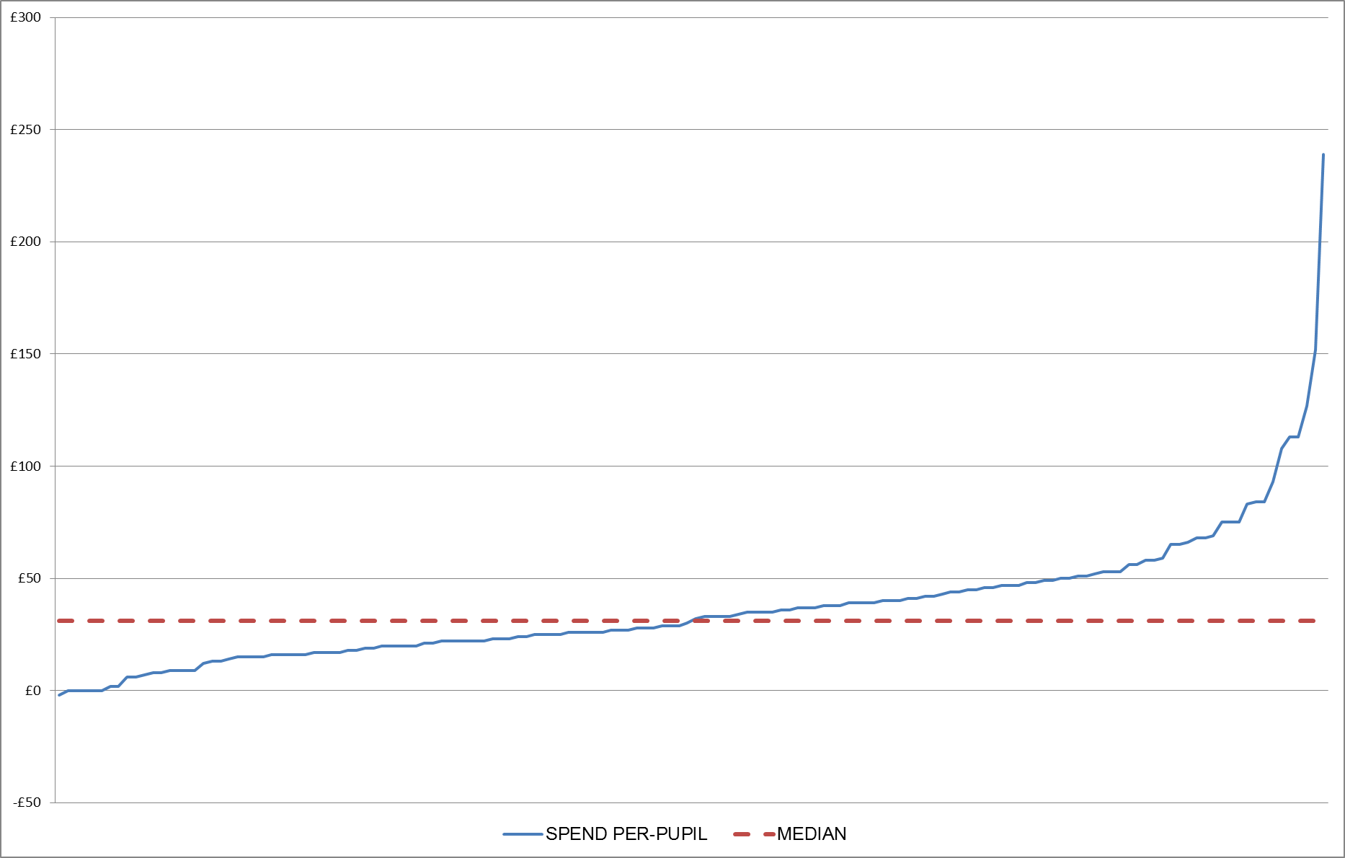
Chart 1 – Distribution of local authority per pupil spend on maintained school pupils and the median (ESG budget line 2.0.4 – school improvement)

A large majority of respondents to this question (74%) felt that further clarification or guidance from the department on the role of local authorities in school improvement would be needed in order to have a clear set of expectations. We anticipate that the revised statutory guidance on schools causing concern (May 2014) will serve that purpose. We are working with Ofsted so that its inspection guidelines reflect the role of the local authority as described in the guidance.
Other opportunities for savings identified through the consultation include: collaboration between local authorities in order to share expertise; school-to-school support, particularly from teaching schools; using an external provider; greater flexibility in the deployment of key staff; and using daily rates for specific projects rather than permanent arrangements.
On this basis, we think it is reasonable to assume that some local authorities could reduce spending considerably in this area, with many higher spenders moving closer to – or below – the observed median planned spend in 2013-14. Furthermore, given that we have not yet found evidence of a relationship between spend on school improvement and improvement in the performance of schools we think that many local authorities could make savings without risk to delivery.

Statutory and regulatory duties
The range of planned spend in 2013-14 on statutory and regulatory duties for maintained schools is illustrated in Chart 2 below. We have adjusted planned spend by removing the funding for retained duties⁵.
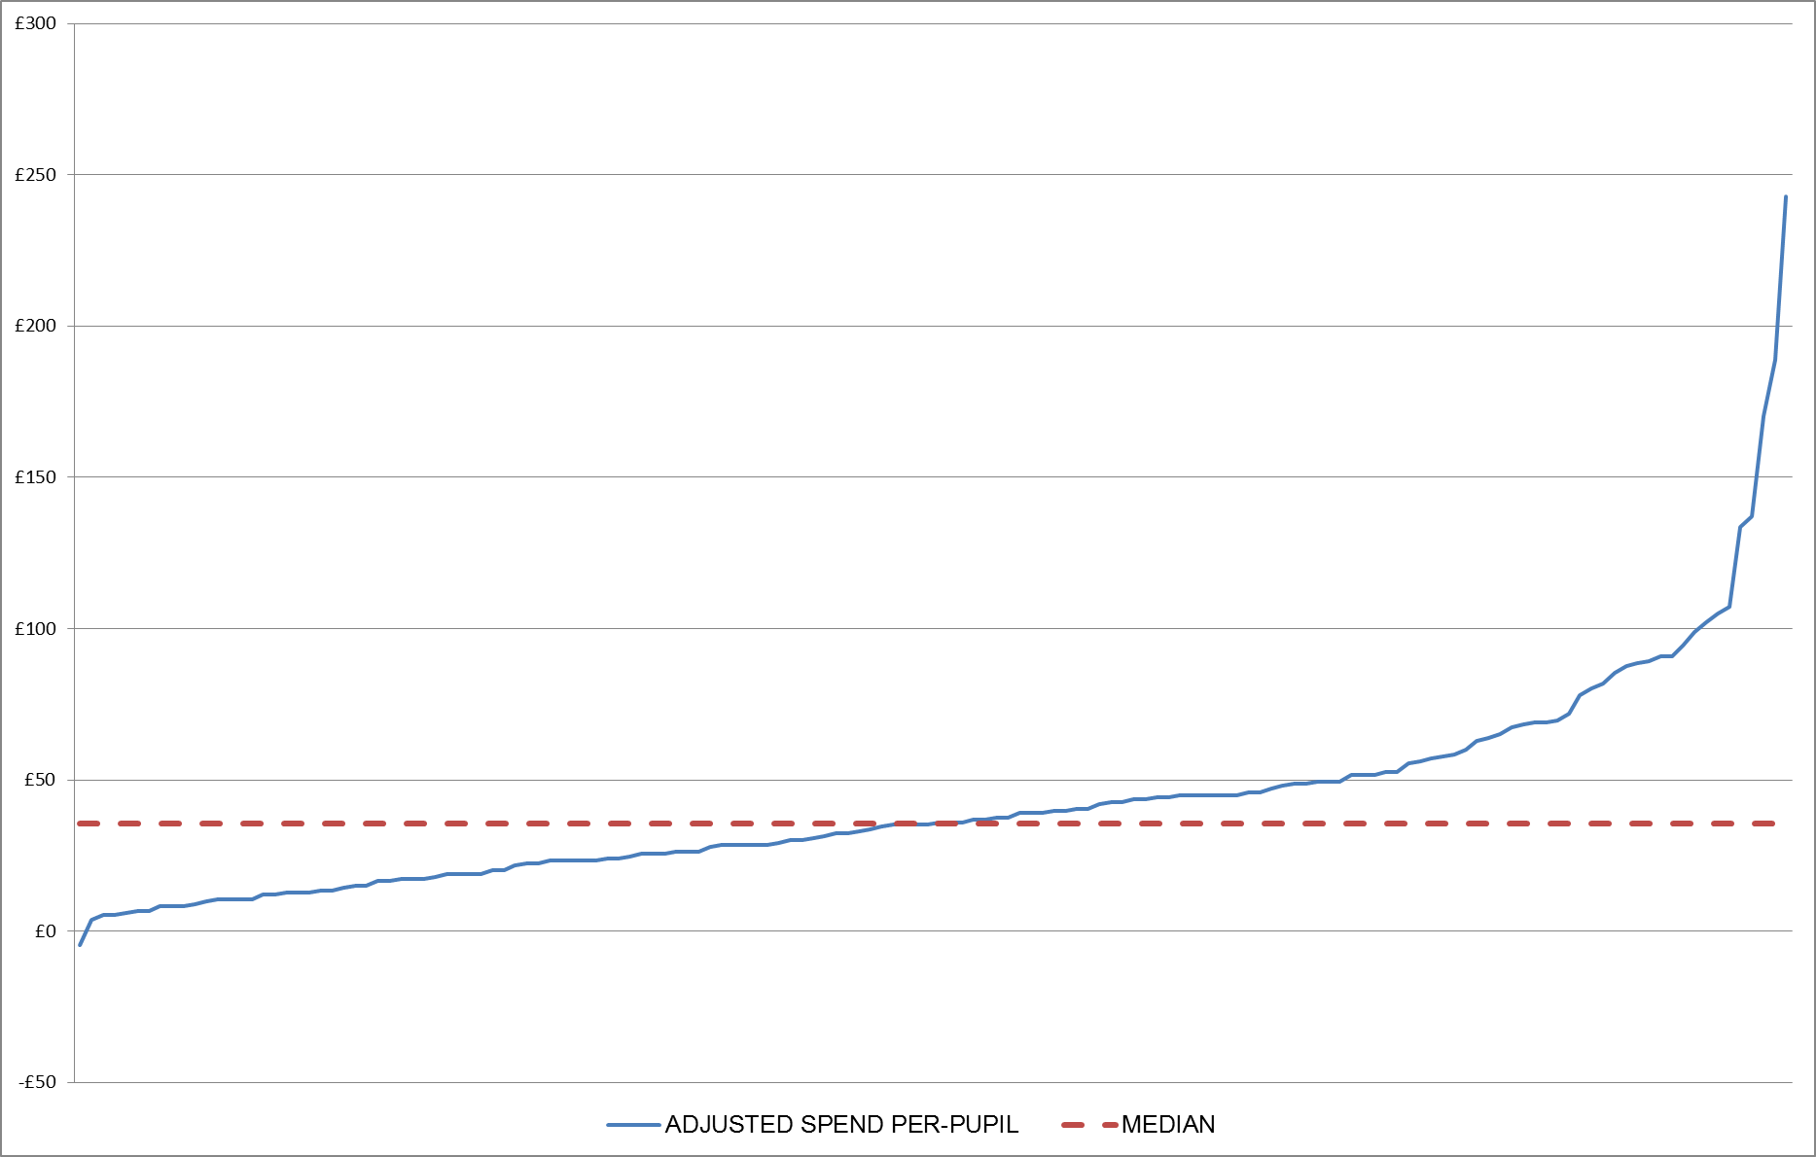
Chart 2 – Distribution of local authority per pupil spend on maintained school pupils and the median (ESG budget line 2.0.6 – statutory and regulatory duties)
The main opportunities for reducing costs and making savings identified through the consultation were:
- collaboration, for example sharing procurement or audit services across the whole local authority, or with other local authorities;
- reducing spend on back-office functions, for example by establishing an independent provider to provide these at lower cost; and
- transferring costs of some functions to schools, for example audit and health and safety.
A key feature of this budget line is that local authorities retain some duties for both academies and maintained schools. As we have discussed in the section above, we have decided to maintain the retained duties rate at £15 per pupil.
A high proportion of respondents asked for further clarification of these duties. We have provided this clarification in Annex A. On the basis of this clarification, the current wide range of reported spend, and the opportunities for savings identified above, we are confident that a significant number of local authorities should be able to reduce their spending on this function.

Education welfare services
The range of planned spend in 2013-14 on education welfare services for maintained schools is illustrated in Chart 3 below. We have adjusted planned spend by removing the funding for retained duties⁵.
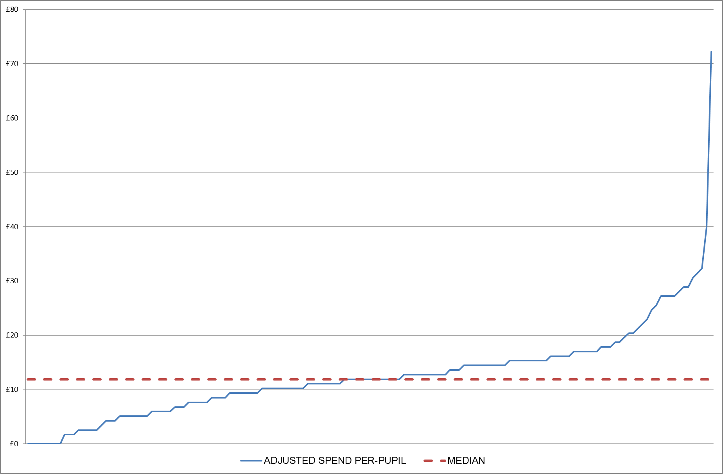
Chart 3 – Distribution of local authority per pupil spend on maintained school pupils and the median (ESG budget line 2.0.3 – education welfare services)
We know that education welfare is an area where many local authorities have already made savings and reduced services to the statutory minimum. We did, however, receive responses suggesting that clarification of duties might allow some local authorities to deliver these services at lower cost. Examples cited included schools taking more responsibility for their statutory obligations according to the England (Pupil Registration) Regulations 2006 and subsequent amendments, and joint working between services across the authority.
A key feature of this budget line is that local authorities retain some duties for both academies and maintained schools. As we have discussed in the section above, we have decided to maintain the retained duties rate at £15 per pupil.
We have provided clarification in Annex A of the relevant statutory duties. On the basis of this clarification, the current wide range of reported spend, and the opportunities for savings identified above, we are confident that a significant number of local authorities should be able to reduce their spending on this function.

Central support services
The range of planned spend in 2013-14 on central support services is illustrated in Chart 4 below.
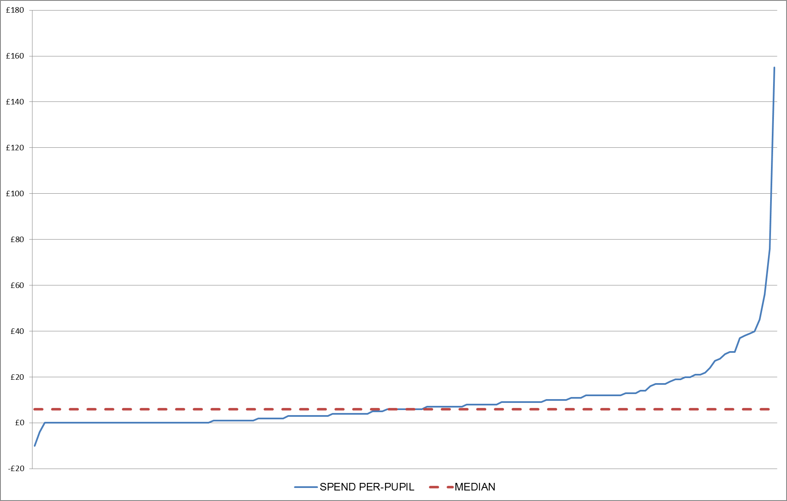
Chart 4 – Distribution of local authority per pupil spend on maintained school pupils and the median (ESG budget line 2.0.2 – central support services)
The consultation document stated that we believe the role for local authorities in providing central support services is limited and that local authorities could commission services on behalf of schools or charge where appropriate. This section of the consultation attracted the vast majority of responses because we said that our expectation was that music services should now be funded through music education hubs (which can cover one or more local authority areas) and from school budgets, not from the ESG.
Respondents expressed concerns about local authorities reducing spend on music and the impact this would have on disadvantaged families and on local culture. Almost everyone reported that they would like to see further clarification or guidance from the department on the expectations relating to this function. A number of local authority respondents reported that because there were no specific obligations for them to provide central support services, they were not incurring any expenditure, either because they have no activity or because they are charging for services. The median spend on this line is £6 per pupil, but more than 30 authorities planned to spend £0, and some authorities made clear they had not incurred spend on these services for some years.
Because of the strong interest and concern around music services (with few concerns expressed about any other aspect of central services), we have addressed the question of music services and music hubs separately in Chapter 5. Here we set out our position on the funding of music education and the additional £18 million announced in parallel.

Asset management
The range of planned spend in 2013-14 on asset management for maintained schools is illustrated in Chart 5 below. We have adjusted planned spend by removing the funding for retained duties⁵.
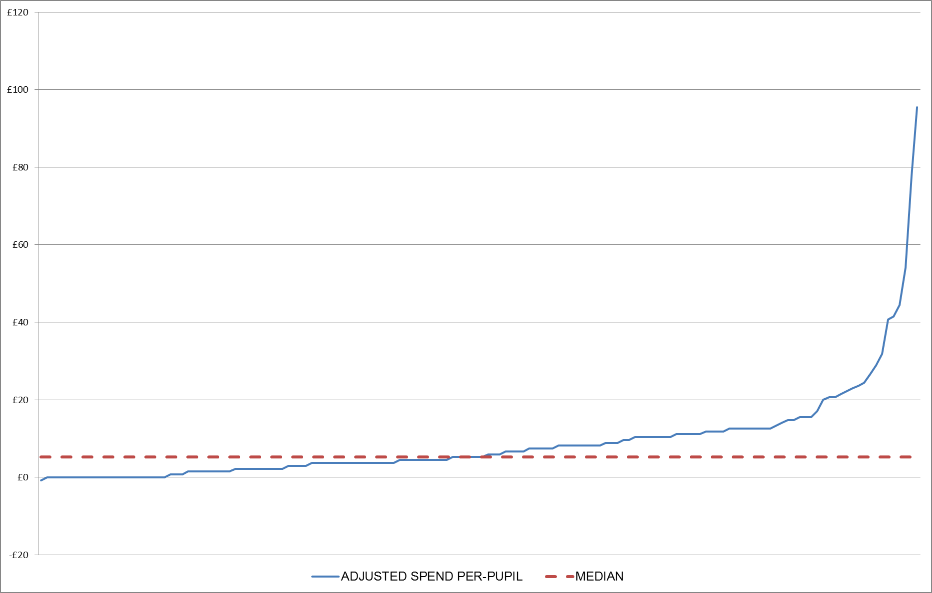
Chart 5 – Distribution of local authority per pupil spend on maintained school pupils and the median (ESG budget line 2.0.5 – asset management)
Consultation respondents highlighted a number of services that were classified as asset management. These related to capital programme planning, management of private finance initiatives and administration of academy leases. Few respondents reported scope for savings given the statutory nature of the function. As a result, we have not yet found a satisfactory explanation for the wide range of reported spend. Many local authorities are already joining up asset management functions across services to realise savings; where local authorities are not, they could perhaps consider doing so. We will consider further whether there is merit in providing new, clearer, information on the roles and responsibilities for school asset management for local authorities and other bodies within the system.
Again, a key consideration of this function is that local authorities retain some duties for both academies and maintained schools. As we have discussed in the section above, we have decided to maintain the retained duties rate at £15 per pupil.
On the basis of the current wide range of reported spend, we are confident that some local authorities currently spending well above the median should be able to reduce their spending towards – or below – the median.

Premature retirement and redundancy costs
The range of planned spend in 2013-14 on premature retirement and redundancy costs is illustrated in Chart 6 below. It shows the majority of local authorities planned no spend in this area.
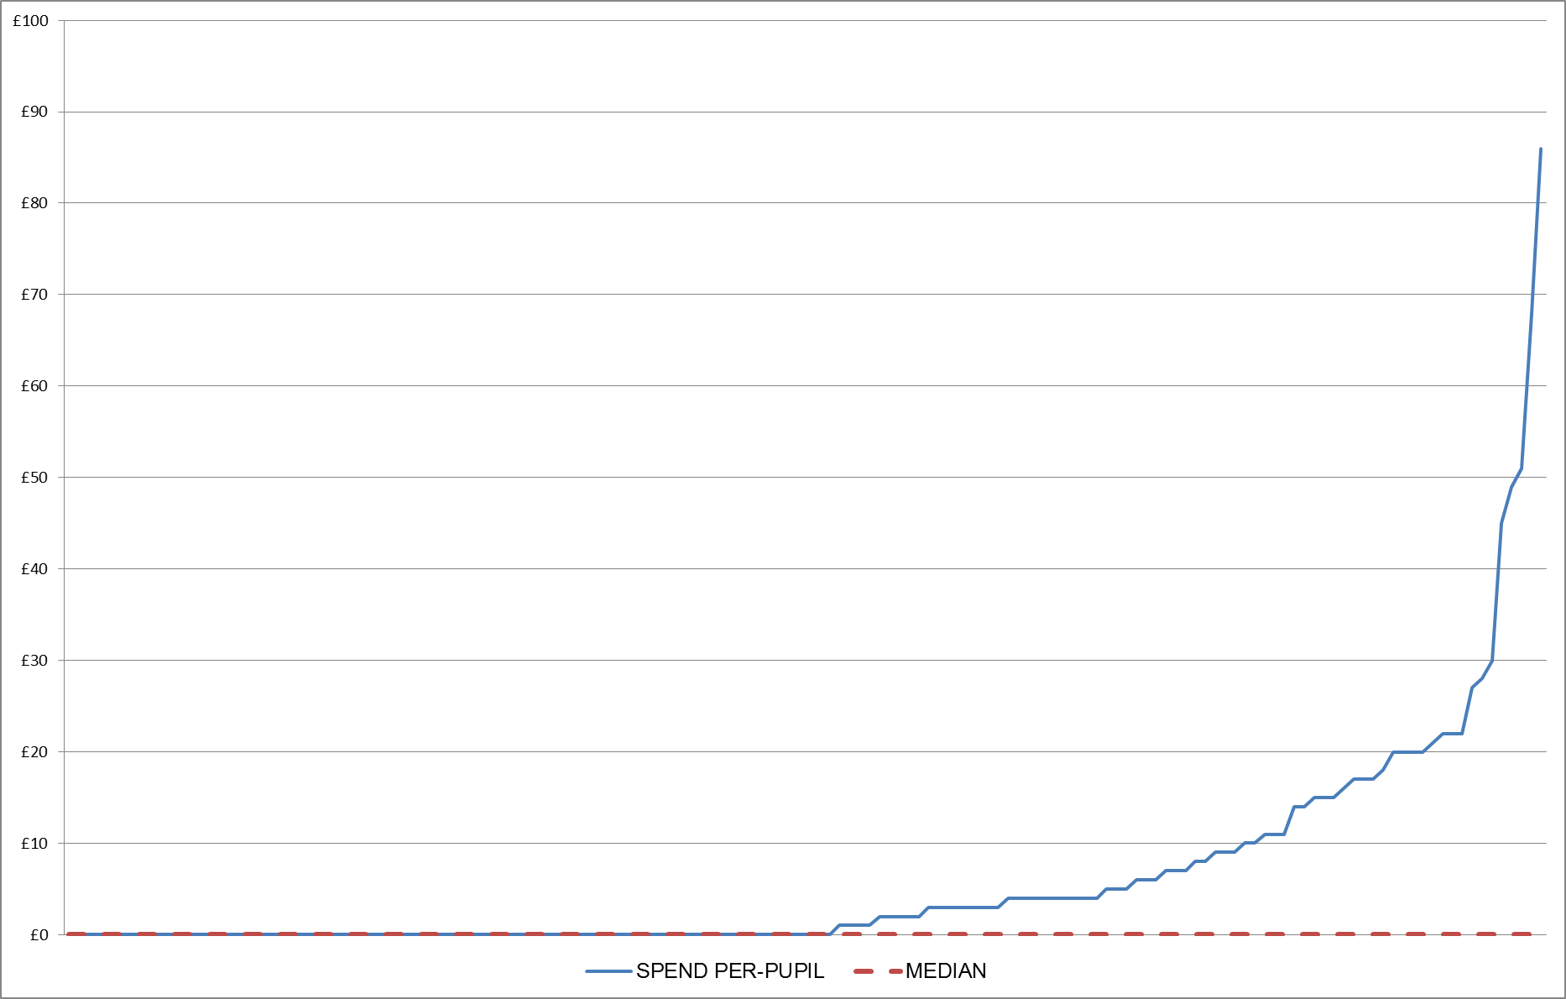
Chart 6 – Distribution of local authority per pupil spend on maintained school pupils and the median (ESG budget line 2.0.7 – premature retirement costs / redundancy costs (new provisions))
The statutory framework requires schools to pay for early retirement and for local authorities to fund redundancy costs in maintained schools by default unless there are good reasons not to. It is clear from consultation responses and fieldwork that local authorities are not covering the costs of early retirement, but practice varies on redundancy costs. Some local authorities have a local agreement that schools will meet the costs; others choose to bear all the costs themselves. The main barriers to passing costs to schools were cited as schools in financial difficulty and those facing falling rolls where it was not deemed appropriate for the school to pick up the cost. The median planned spend on this line was £0 and 78 local authorities did not plan to spend anything on premature retirement or redundancies in 2013-14.
We think that this is an area of spend where the current observed median planned spend of £0 may be difficult to achieve in some local authorities. This might be, for example, because they have schools in circumstances such that that they cannot afford to pay redundancy costs.

Therapies and other health-related services
The range of planned spend in 2013-14 on therapies and other health-related services is illustrated in Chart 7 below. Again it shows the majority planned no spend in this area.
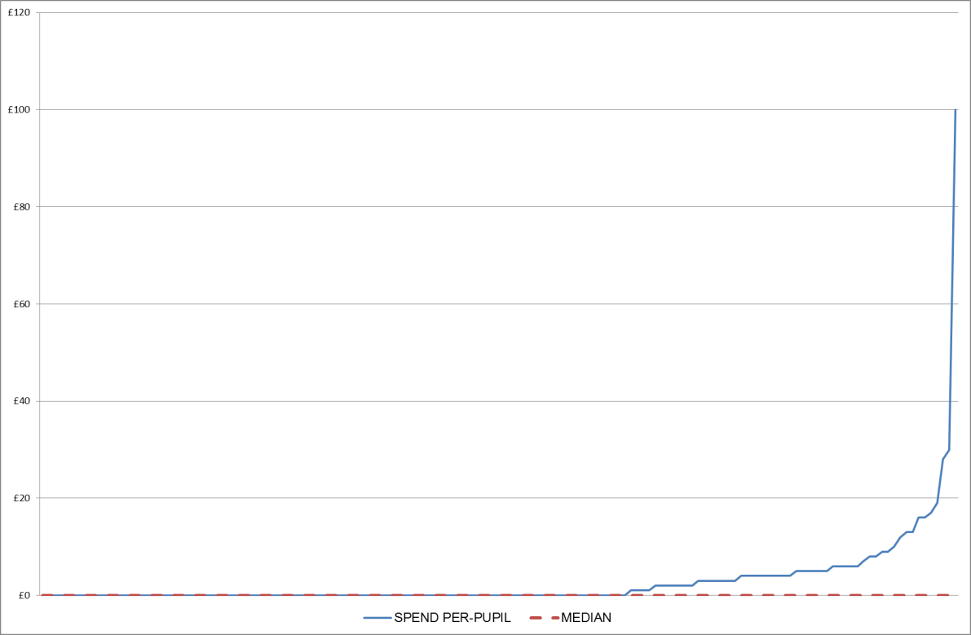
Chart 7 – Distribution of local authority per pupil spend on maintained school pupils and the median (ESG budget line 2.0.1 – therapies and other health-related services)
A number of respondents queried why therapies was listed as an ESG related function (or included in LACSEG) when it tended to be a service for pupils with high needs. Most local authority respondents said they use their high needs block funding to pay for these services, although some said that if their DSG was too low they would need to supplement it from ESG. The median planned spend on this line was £0 and 96 local authorities did not plan to spend anything on therapies and other health-related services in 2013-14.
Given variable high needs arrangements across the country we recognise some local authorities might find it more difficult to make savings in this area than others and that the current observed median planned spend of £0 may not be achievable for some.

Monitoring national curriculum assessment
The range of planned spend in 2013-14 on monitoring national curriculum assessment is illustrated in Chart 8 below. Again it shows the majority planned no spend in this area. We think that this is probably explained by local authorities reporting spend in this area on a different section 251 budget line (often cited as school improvement 2.0.4). A number of local authorities highlighted this in their consultation responses.
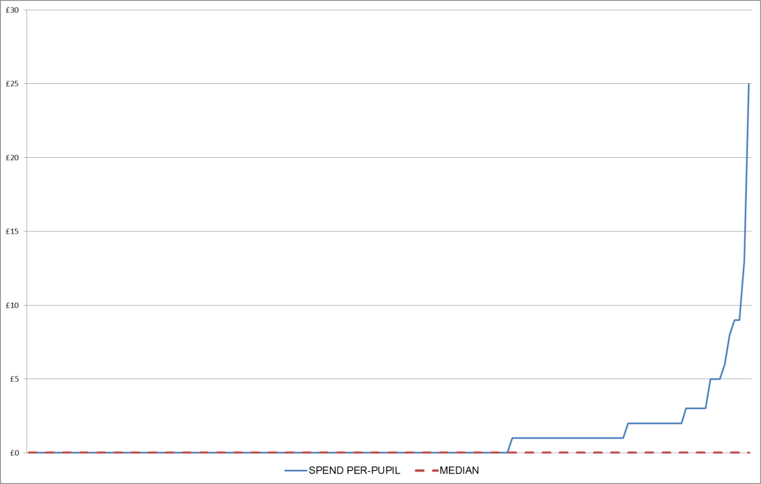
Chart 8 – Distribution of local authority per pupil spend on maintained school pupils and the median (ESG budget line 2.0.8 – monitoring national curriculum assessment)
Local authorities have a statutory duty to monitor the administration of national curriculum assessments in maintained schools and to moderate teacher assessments at key stage 1. The department has provided clear guidance on local authorities’ responsibilities for monitoring and moderation .
In addition, local authorities can contact the Standards and Testing Agency helpline on 0300 303 3013 for further advice.
A small number of respondents suggested that savings could be made on this function through greater use of school-based staff or through cross-school moderation.
There were mixed views reported on whether it was appropriate for local authorities to charge schools for something they are bound by statute to provide. We are able to provide some clarification on this question. Local authorities cannot charge maintained schools for national curriculum assessments, although academies may be charged.
We do not anticipate that monitoring or moderation of the new national curriculum end of key stage tests will result in significant cost pressures for local authorities, but will keep this under review.

Chapter 2 – How a local authority might choose to spend ESG in 2015-16
As ESG is an un-ringfenced grant, it is entirely at the discretion of local authorities how the funding is spent. Different local authorities will have different needs and thus rightly make different choices about how to use their ESG funding. However, in order to demonstrate further why we are satisfied that a general funding rate of £87 is sufficient, we provide the following illustrations of how a local authority might choose to spend its ESG funding and how this compares with planned spending in other local authorities.
We want to be clear that these illustrations are not intended as a guide to how local authorities ought to spend ESG. We recognise the importance of local discretion and a degree of necessary variation in service provision across the country.
Our first illustration (Table 2) uses the median of local authority planned spending in 2013-14 as a starting point for possible spend on each line. It shows the number of local authorities that were planning to spend at or below this level.
In doing this we recognise that each local authority has different circumstances and that some authorities spend more than the median on some functions for good reasons, just as others spend less for equally good reasons. We know, however, that at present there is no correlation between high spend on one service and high spend on another service, meaning that it is reasonable to assume that in the vast majority of cases higher spend on one line could be offset by lower spend on another line. Our analysis also shows that about a third of local authorities with different characteristics (see Chapter 1 - general funding rate – and Annex B) planned spend in 2013-14 on maintained school pupils at a rate around or below £87 per pupil.
As we have highlighted in Charts 1-8 in Chapter 1, the median planned spend in 2013-14 for some functions was £0 (premature retirement, therapies and monitoring national curriculum assessment). Table 2 shows a local authority spending slightly above the median on these lines to reflect the fact that, in some circumstances, some spend may be necessary in these areas.
The only function in this illustration that shows spending below the current median is central support services (£1.30 – the 35th percentile – rather than the median of £6). There are no statutory duties for this line.

Planned spend on ESG services for pupils in maintained schools only
Section 251 budget line | Possible expenditure (per maintained school pupil)⁵ | Percentile of 2013-14 LA planned expenditure
2.0.3 Education welfare services | £11.90 | Median  (82 LAs planned to spend at or below)
2.0.4 School improvement | £31.00 | Median  (75 LAs planned to spend at or below)
2.0.5 Asset management - education | £5.20 | Median  (76 LAs planned to spend at or below)
2.0.6 Statutory and regulatory duties - education | £35.60 | Median  (75 LAs planned to spend at or below)
2.0.7 Premature retirement costs / redundancy costs (new provisions) | £1.00 | 54th percentile  (82 LAs planned to spend at or below)
2.0.8 Monitoring national curriculum assessment | £0.50 | 67th percentile  (100 LAs planned to spend at or below)
2.0.1 Therapies and other health-related services | £0.50 | 64th percentile  (96 LAs planned to spend at or below)
2.0.2 Central support services | £1.30 | 30th percentile  (45 LAs planned to spend at or below)
Total spend on ESG services for maintained school pupils only | £87.00 | 48 LAs planned to spend at or below this level
Table 2 – potential spend based on median spending patterns (general funding rate)

This is absolutely not intended as an instruction of how local authorities ought to spend their ESG. It simply illustrates how a local authority might provide the services for which ESG is intended without spending less than the current median for any service, with the exception of central support services where there are no statutory duties.
Our second illustration (Table 3) shows a pattern of spending which, if followed by all local authorities, would mean that the total national spend on each spending line would fall by 23% from 2013-14 levels. We are absolutely not suggesting that any local authority ought to follow this pattern of spending. Again, this is simply an illustration.

Planned spend on ESG services for pupils in maintained schools only
Section 251 budget line | Possible expenditure (per maintained school pupil)⁵ | Percentile of 2013-14 LA Spending
2.0.3 Education welfare services | £8.65 | 29th percentile  (44 LAs planned to spend at or below)
2.0.4 School improvement | £27.01 | 45th percentile  (68 LAs planned to spend at or below)
2.0.5 Asset management - education | £7.41 | 58th percentile  (88 LAs planned to spend at or below)
2.0.6 Statutory and regulatory duties - education | £28.14 | 37th percentile  (56 LAs planned to spend at or below)
2.0.7 Premature retirement costs / redundancy costs (new provisions) | £5.82 | 72nd percentile  (108 LAs planned to spend at or below)
2.0.8 Monitoring national curriculum assessment | £0.54 | 67th percentile  (100 LAs planned to spend at or below)
2.0.1 Therapies and other health-related services | £1.67 | 67th percentile  (100 LAs planned to spend at or below)
2.0.2 Central support services | £7.76 | 58th percentile  (87 LAs planned to spend at or below)
Total spend on ESG services for maintained school pupils only | £87.00 | 48 LAs planned to spend at or below this level
Table 3 - potential spend based on 23% reduction to planned spend
on each line (general funding rate)

Chapter 3 – Impact on academies
At present, academies receive higher levels of ESG than local authorities. In academic year 2014/15, all academies will receive an ESG top-up of £27 per pupil and a protection that ensures that the loss incurred by any academy as a result of the changes in ESG and SEN LACSEG in that year cannot exceed 1% of its total budget (including its post-16 funding) in academic year 2013/14.
We have been clear since the introduction of ESG in 2013 that, over time, the ESG rates for academies will converge with those for local authorities. In 2015/16, we are changing ESG protections for academies to help us continue to achieve that aim.
In academic year 2015/16, there will be no top-up for academies, but in order to protect academies against large budget reductions, they will continue to receive protection against reductions to ESG and the removal of SEN LACSEG.
The new protection for academies will be set in tapered bands, so that academies that are currently receiving low ESG payments will still not be allowed to see a fall of more than 1% of their total funding, while academies that are currently receiving relatively high ESG payments (because they used to have high levels of LACSEG) will be allowed to see a fall of more than 1% in their total funding (up to a maximum of 3%). This new protection will therefore drive convergence between the academy and local authority ESG rates and move towards a fairer distribution of funding between academies.
Each academy will have its own level of protection defined by its level of ESG per pupil in academic year 2014/15. An individual academy’s protection rate – which sets the maximum total percentage budget loss permitted due to changes in ESG and SEN LACSEG – in 2015/16 will be calculated as follows:
- £140; plus
- twice the amount of ESG⁸ per pupil that the academy receives between £140 per pupil and £160 per pupil; plus
- three times the amount of ESG⁸ that the academy receives over £160 per pupil; and then
- that total is divided by the total amount of ESG⁸ that the academy receives per pupil, to give a percentage protection rate.
This is illustrated in the worked example and the table of protection rates, shown below.
This arrangement means that a small number of academies that currently receive exceptionally high rates of ESG will see reductions approaching 3% of their budgets – but the vast majority of academies will enjoy a tighter protection. The vast majority of academies will have a protection such that their ESG⁸ cannot fall by more than 1.5% of their total budget. It is furthermore important to note that not all of these academies will lose as much as 1.5% of their total budget as a result of changes to ESG; many – especially those already on low rates of ESG – will see a much smaller percentage reduction.
The following worked example shows how we would calculate the protection for an illustrative academy.
Academy A
In 2014/15:
Its total per-pupil funding – including the dedicated schools grant (DSG), post-16 funding, ESG and previous ESG protection funding in 2014/15 – is £5,500. This £5,500 includes £465 per pupil (pp) comprised of:
- ESG of £140pp;
- Previous ESG protection funding of £300 pp; and
- SEN LACSEG of £25 pp.
In 2015/16:
Without protection the academy would lose:
- £53pp from the ESG reduction from £140 to £87;
- £300pp from the removal of the ESG protection; and
- £25pp from the removal of SEN LACSEG.
- Making a total loss of £378.
But there is protection in 2015/16. The protection rate for the academy is calculated as follows:
- £140 * 1 +
- £20 * 2 +
- £305 * 3
- Giving a total of £1,095 which is then divided by £465 to give a protection rate of 2.36%
The protection rate of 2.36% is applied to the total budget of £5,500 to give a maximum loss of £130pp. Against a starting gross loss of £378pp the academy has therefore received £248pp of protection.

Table 4 below shows the rate of protection that academies will receive in 2015/16, based on a series of 2014/15 per pupil funding rates for ESG and SEN LACSEG after protection is applied. This is not an exhaustive list: some academies will have significantly higher per pupil rates than £240 in 2014/15.
£pp ESG8  Funding Rate (14/15) | % Protection in 2015/16 | £pp ESG8  Funding Rate (14/15) | % Protection in 2015/16 | £pp ESG8 Funding Rate (14/15) | % Protection in 2015/16
140 | -1.00% | 175 | -1.29% | 210 | -1.57%
145 | -1.03% | 180 | -1.33% | 215 | -1.60%
150 | -1.07% | 185 | -1.38% | 220 | -1.64%
155 | -1.10% | 190 | -1.42% | 225 | -1.67%
160 | -1.13% | 195 | -1.46% | 230 | -1.70%
165 | -1.18% | 200 | -1.50% | 235 | -1.72%
170 | -1.24% | 205 | -1.54% | 240 | -1.75%
Table 4 – Summary of protection rates

Rates for alternative provision academies and special academies
Many of the functions that ESG was intended to fund relate to staff and premises. These include asset management, administering pension contributions, advising on terms and conditions of non-teaching staff and appointment checks and dismissals. Special schools / special academies and pupil referral units (PRUs) / alternative provision (AP) academies have much higher staffing ratios per pupil, and need more space per pupil, as a result of smaller group sizes and the intensive support they offer. The teacher to pupil ratio in these schools is around four to five times higher than in mainstream settings. These factors all result in increased overheads and higher staff-related costs.
In summer 2012, we consulted on applying a multiplier to the ESG general funding rate for these institutions of 4.25 and 3.75 respectively for special schools and PRUs / AP. We see no compelling reason why these multipliers need to change and they will remain constant in 2015-16.
For special and AP academies, these multipliers will also be applied to the £140 per pupil and £160 per pupil thresholds of the academies protection described above, to ensure that special and AP academies are not disproportionately affected by the new tapered protection.
Full technical guidance on the revised academy protection arrangements and the rates for alternative provision academies and special academies will be issued in due course.

Chapter 4 – Clarification of duties in relation to education services
Analysis of consultation responses demonstrates that clarification of local authorities’ duties to provide education services to academies and maintained schools would be welcomed and could also help with achieving savings.
The table in Annex A lists the main duties that local authorities have in education services in relation to both maintained schools and academies. Local authorities may wish to use this information when considering their provision of services for schools, and we hope that it will be helpful for academies to have clarity about the duties that local authorities retain for them.

Chapter 5 – Additional funding for music services
We believe that every child is entitled to a high-quality music education. We have confirmed music as a compulsory subject for all children from key stage 1 to key stage 3 in the new national curriculum. The new programmes of study for music include an increased focus on the need for activities to be undertaken ‘musically’ with reference to learning to play a musical instrument and an increased focus on singing.
In November 2011 we announced that we would set up new music education hubs to improve the quality and consistency of music education. Music hubs are responsible for ensuring that every child has access to free whole class ensemble tuition for at least one term, providing affordable progression routes to all young people who wish to develop their skills even further, providing opportunities for young people to play in ensembles, and developing a singing strategy to ensure that every young person sings regularly. We are providing £171 million for hubs across 2012-15, and in 2015-16 at least £75 million, compared with £58 million in 2014-15.
Government funds music education hubs centrally, according to a formula which reflects total pupil numbers and the number of pupils in each area who are eligible for free school meals, and music education hubs are also encouraged to seek other sources of funding. If they wish, local authorities can choose to supplement this central funding from their non-ringfenced budget, including ESG.
There are additional programmes funded by The department which support children from deprived areas and low-income families to access an excellent music education. We are providing over £84 million across 2012-15 for the Music and Dance Scheme (MDS), which provides means-tested financial assistance for children with exceptional potential so that they can benefit from world-class specialist training, and we are also providing £1.5 million for ‘In Harmony’ across the 2012-15 period.
The department received a large volume of responses to the consultation on ESG relating to the provision of music services. Concern was triggered by our statement in the consultation document that our expectation was that music services should now be funded through music education hubs (which can cover one or more local authority areas) and from school budgets, not from the ESG. Many respondents were concerned that reduced local authority support for music services would impact on the overall quality of music provision and in particular on the opportunities for disadvantaged children.
In 2014-15 The department for Education gave central funding of £58 million to music hubs. At present, we do not have reliable data on the amount of extra funding that local authorities gave to music hubs in 2014-15. Data collected by Arts Council England suggests that, in 2012-13, local authorities contributed just over £14 million to music hubs.
In recognition of the importance of high quality music education, we have announced in parallel that in 2015-16 we will increase central funding to music education by £18 million. The total funding for music education hubs will be around £75 million 2015-16 – up from £58 million in 2014-15.
As ESG is an un-ringfenced grant, local authorities will continue to have total discretion about whether to spend any of the ESG budget they receive on providing music services.

© Crown copyright 2014
You may re-use this document/publication (not including logos) free of charge in any format or medium, under the terms of the Open Government Licence v2.0. Where we have identified any third party copyright information you will need to obtain permission from the copyright holders concerned.
To view this licence:
visit www.nationalarchives.gov.uk/doc/open-government-licence/version/2
email psi@nationalarchives.gsi.gov.uk
About this publication:
enquiries www.education.gov.uk/contactus
download www.gov.uk/government/publications
Reference: [000-000-000]
 | Follow us on Twitter: @educationgovuk |  | Like us on Facebook:  facebook.com/educationgovuk

Academies receive their funding on an academic year basis, whereas local authorities receive it on a financial year basis.
For pupils in alternative provision and special schools multipliers of 3.75 and 4.25 respectively are applied on a per place basis to the rates and top-up shown.
Academies used to receive money from DfE for SEN services as part of the schools block Local Authority Central Spend Equivalent Grant (LACSEG). From 2011-12 local authorities were given responsibility for providing such services to academies free of charge, so academies were being double funded.This element of LACSEG continued to be paid directly to academies until academic year 2012/13. It ceased to be paid in academic year 2013/14 but was included in academies’ baselines for calculation of the minimum funding guarantee. We announced in February 2014 that the Education Funding Agency would recover the overpayment made in academic year 2012/13. The adjustment is being made over two academic year allocations: 50% in 2014/15 and 50% in 2015/16. Academies are protected from excessive year-on-year turbulence as a result of this change, through the transitional protection as set out in Chapter 3.
As in previous years, protection funding for academies will continue to be funded from a part of the Department's budget outside the ESG, not from the ESG itself.
This is after spend on retained duties has been accounted for. For the three ESG relevant functions where local authorities retain some duties on behalf of academies we have applied an adjustment for retained duties. We have assumed that the percentage of total spend on each line for retained duties is as follows: education welfare services, 15%; statutory and regulatory duties, 25%; and asset management, 26%. These splits are the same as those applied to former LACSEG rates.
Figures 4 and 5 in Annex B of our consultation document illustrated the relationship between spend on school improvement and % change in key stage 2 and 4 attainment rates. It can be found here: https://www.gov.uk/government/uploads/system/uploads/attachment_data/file/321286/Consultation_Document.pdf
See Footnote 3.
Including SEN LACSEG and after the current protection has been applied

