Prisons Commissioning Status Summary – April 2012
- Roleof the prison representative on the local partnership commissioning team
- Has the CARAT contract been novated?
- Where there are directly employed prison staff, is there a local agreement/MoU to provide interim cover until the new service is operational?
- Has the needs assessment been completed? If not, when is the NA scheduled to be completed?
- Has alcohol been included in the needs assessment?
- Is the partnership intending to put the entire service (clinical and psychosocial) to tender of just the psychosocial?
- When will the ITT be published?
- When is the re-tendered service scheduled to become operational?

- Role of the prison representative on the local partnership commissioning team

National:
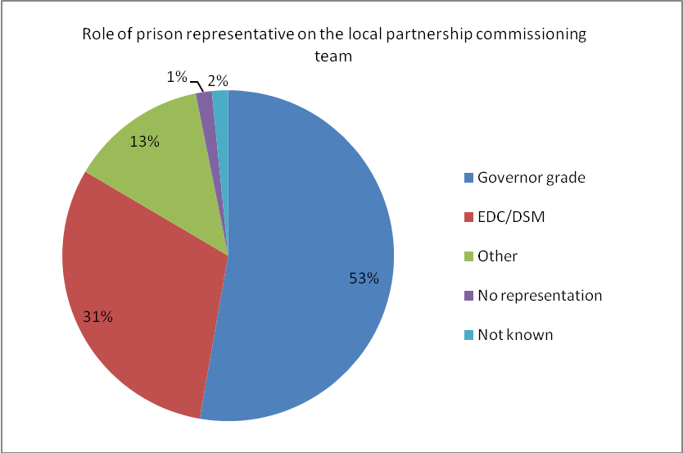

Regional:
Region | Governor | EDC / DSM | Other | No representation | Not known
East Midlands | 8 | 4 | 3
East |  | 9 | 6
London | 4 | 4 |  | 1
North East | 2 | 6
North West | 2 | 5 | 3 | 1 | 4
South East | 22 | 4
South West | 11 | 1 | 1
West Midlands | 10 | 1 | 1
Yorkshire & Humber | 8 | 4 | 2
NATIONAL | 67 | 38 | 16 | 2 | 4

No representation as yet for HMP Thameside.
No representation for HMP Forest Bank due to low numbers of Salford prisoners.

- Has the CARAT contract been novated?
National:
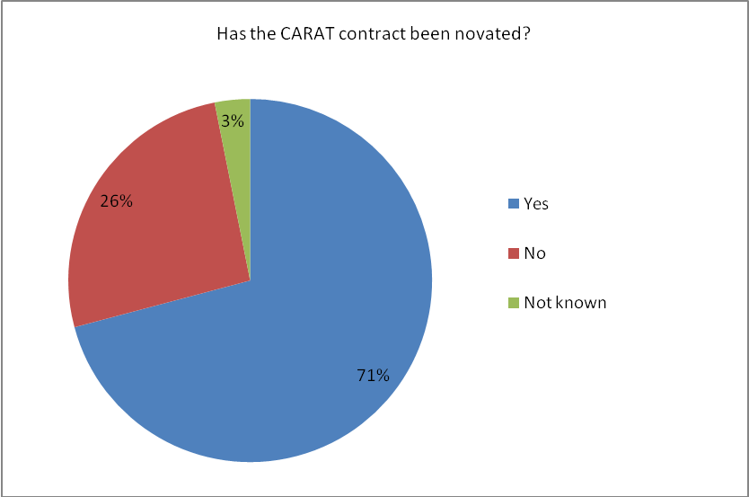

Regional:
Region | Yes | No | Not known
East Midlands | 7 | 8
East | 13 | 2
London | 7 |  | 2
North East |  | 7 | 1
North West | 12 | 2 | 1
South East | 25 | 1
South West | 13
West Midlands | 7 | 5
Yorkshire & Humber | 6 | 8
NATIONAL | 90 | 33 | 4

- Where there are directly employed prison staff, is there a local agreement/MoU to provide interim cover until the new service is operational

National:
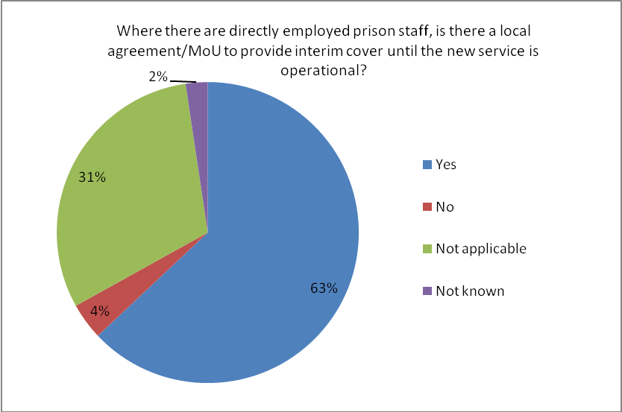

Regional:
Region | Yes | No | Not applicable | Not known
East Midlands | 9 |  | 6
East | 7 |  | 8
London | 6 |  | 1 | 2
North East | 8
North West | 14 | 1
South East | 9 | 2 | 15
South West | 11 |  | 1 | 1
West Midlands | 8 | 2 | 2
Yorkshire & Humber | 8 | 6
NATIONAL | 80 | 11 | 33 | 3

- Has the needs assessment been completed? If not, when is the NA scheduled to be completed?
National:
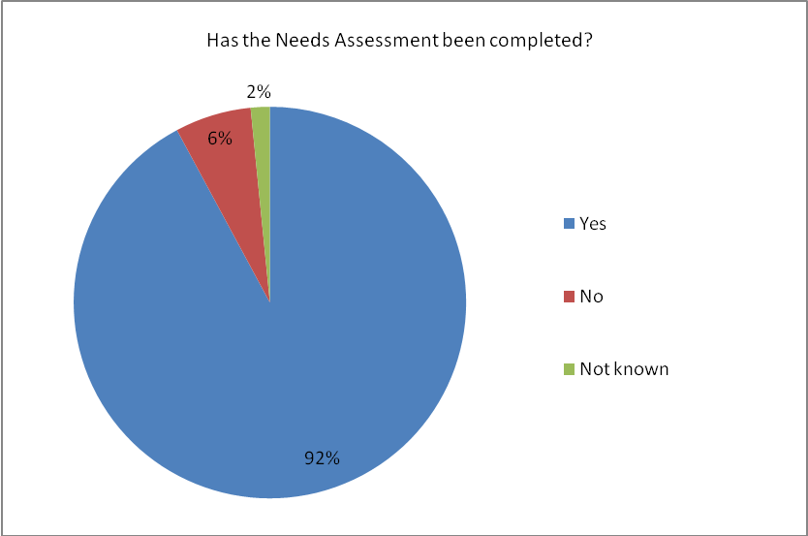
Regional:
Region | Yes | No | Not known
East Midlands | 15
East | 15
London | 7 |  | 2
North East | 8
North West | 12 | 2 | 1
South East | 26
South West | 13
West Midlands | 10 | 2
Yorkshire & Humber | 10 | 4
NATIONAL | 116 | 8 | 3

Where the NA hasn’t been completed it is scheduled for:
Region | Prison | Date
North West | Manchester | Not known
 | Altcourse | Not known
 | Forest Bank | 31st May 2012
West Midlands | Shrewsbury | 30thJune 2012
 | Stoke Heath | 30th June 2012
Yorkshire &Humber | Askham Grange | 1st April 2012
 | Northallerton | 5th May 2012
 | Wakefield | 1st June 2012
 | New Hall | 1st June 2012

- Has alcohol been included in the needs assessment?
National:
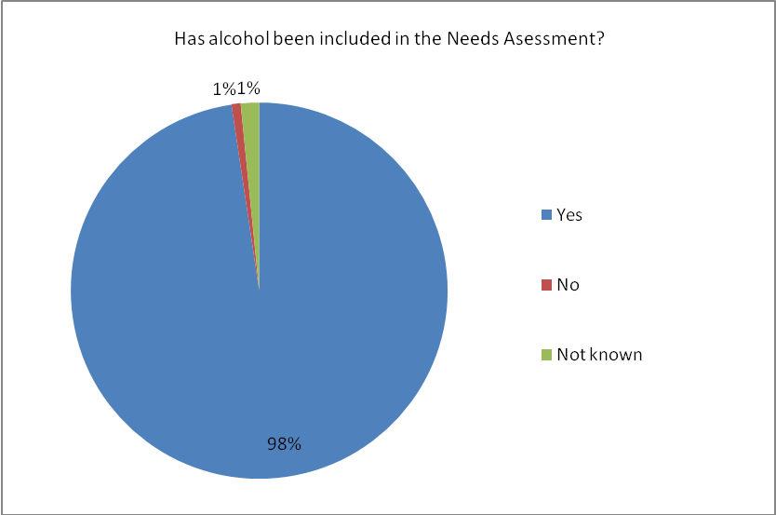
Regional:
Region | Yes | No | Not known
East Midlands | 15
East | 15
London | 8 |  | 1
North East | 8
North West | 13 | 1 | 1
South East | 26
South West | 13
West Midlands | 12
Yorkshire & Humber | 13 |  | 1
NATIONAL | 123 | 1 | 3

- Is the partnership intending to put the entire service (clinical and psychosocial) to tender or just the psychosocial?
National:
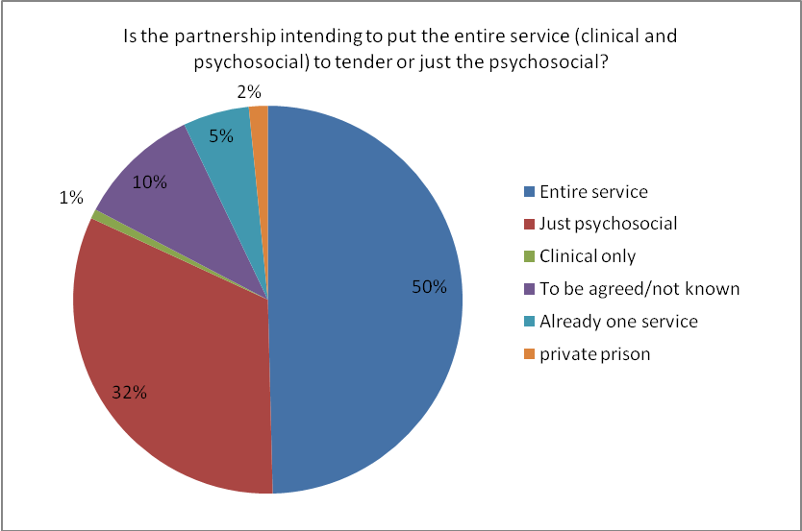

Regional:
Region | Entire service | Just psychosocial | Clinical only | Already one service | To be agreed / not known / private prison
East Midlands | 10 | 3 | 1 | 1
East | 1 | 12 |  |  | 2
London |  | 7 |  | 1 | 1
North East |  | 8
North West | 10 | 1 |  | 1 | 3
South East | 24 | 2
South West | 5 | 4 |  |  | 4
West Midlands | 10 |  |  |  | 2
Yorkshire & Humber | 3 | 4 |  | 4 | 3
NATIONAL | 63 | 41 | 1 | 7 | 15

- When will the ITT be published?
National:
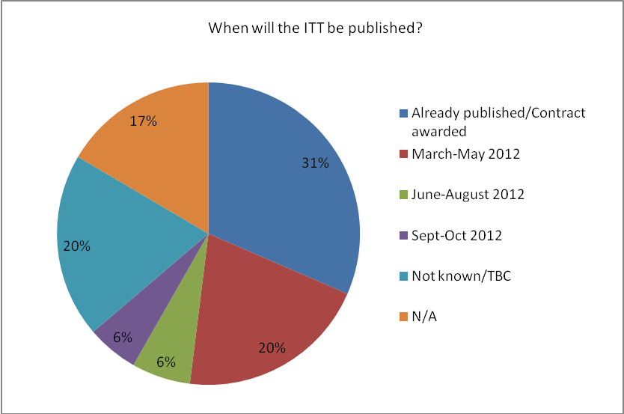
Regional:
Region | Already published / Contract awarded | March-May 2012 | June-Aug 2012 | Sept-Oct 2012 | Not known / TBC | Not applicable
East Midlands | 4 |  | 2 | 5 | 1 | 3
East | 11 |  |  |  |  | 4
London | 5 |  | 1 | 2 | 1
North East |  |  |  |  |  | 8
North West | 3 | 1 |  |  | 10 | 1
South East | 1 | 20 |  |  | 5
South West | 4 | 3 | 2 |  | 4
West Midlands | 8 | 2 |  |  | 1 | 1
Yorkshire & Humber | 4 |  | 3 |  | 3 | 4
NATIONAL | 40 | 26 | 8 | 7 | 25 | 21

- When is the re-tendered service scheduled to become operational?
National:
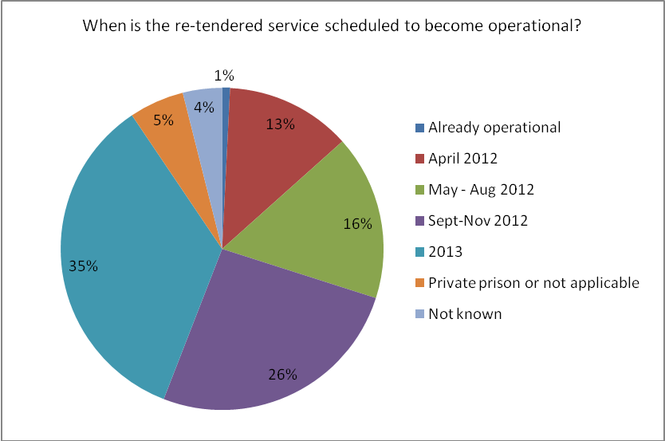
Regional:
Region | Already operational | April 2012 | May – Aug 2012 | Sept-Nov 2012 | 2013 | Private prison or not applicable | Not known
East Midlands |  | 4 | 3 |  | 8
East |  | 7 | 1 | 5 | 2
London |  | 1 | 1 | 3 | 3 | 1
North East |  |  |  | 4 | 4
North West |  |  | 1 | 1 | 9 | 1 | 3
South East |  |  | 10 | 12 | 4
South West |  | 3 |  | 1 | 9
West Midlands |  |  | 5 | 4 | 1 | 1 | 1
Yorkshire & Humber | 1 | 1 |  | 3 | 4 | 4 | 1
NATIONAL | 1 | 16 | 21 | 33 | 44 | 7 | 5

